WEEK 4

VACS AI Patient & Grading Issue Report

Final Clinical and Operational Audit

Michael Thompson • Angela Brooks • Robert Jenkins
Prepared by
Mitchell Bowers
PharmD Candidate, Class of 2027
D'Youville University School of Pharmacy
Purpose. This report consolidates the nine Week 4 VACS encounter audits (Tuesday, Wednesday, Thursday for each of three patients) into one document. It highlights potential grading defects, internal EMR inconsistencies, clinically material mismatches, and clear documentation improvements. Each visit retains its supporting rationale and available image evidence.
Evidence policy. Actual AI-patient statements, the current EMR export, the reference rubric, AI-grader feedback, and previous visit reports are kept separate. A grader statement or rubric criterion is not automatically proof of a patient fact. Image evidence is reused from the nine uploaded audit reports and retains each report’s original provenance caveats. Unless an original report expressly verified the live interface, EMR-export findings remain provisional.
Visit order: MT (Tuesday–Thursday) → AB (Tuesday–Thursday) → RJ (Tuesday–Thursday)
Prepared 21 October 2026

Quick Guide for Non-Clinical Readers
Term | Plain-language meaning
AI patient | Simulated patient answering the student’s interview questions.
EMR | Electronic medical record displayed to the student.
Rubric / AI grader | Expected checklist and automated SOAP assessment; a rubric alone is not independent source proof.
SOAP | Clinical note in Subjective, Objective, Assessment, and Plan sections.
AFib / DOAC | Atrial fibrillation / direct oral anticoagulant (for example apixaban).
HFrEF / LVEF | Heart failure with reduced ejection fraction / measured left-ventricular pumping function.
GDMT | Guideline-directed medical treatment; HFrEF commonly uses four foundational drug classes.
CKD / eGFR | Chronic kidney disease / estimated glomerular filtration rate, describing kidney function.
SpO₂ | Oxygen saturation; room-air status must be supported by a source.
BSA / BMI | Body surface area / body mass index; derived from height and weight.
BNP / NT-proBNP | Different heart-failure laboratory tests; their numeric values should not be presented as interchangeable.
LMWH / bridge | Low-molecular-weight heparin / temporary injectable anticoagulation during an interruption.
CHA₂DS₂-VASc | Stroke-risk assessment for atrial fibrillation based on clinical risk factors.

Week 4 Final Review Summary
All nine encounters are included in patient-first, Tuesday-to-Thursday order. Strong grading outcomes do not preclude substantive documentation or EMR defects. The score deductions below are the visible rubric deductions reported by each original individual audit, not a new recalculation of the grader.
Patient | Day / visit | AI score | Visible items / points
MT | Tuesday — Initial Visit | 98.3% | 4 / −1.9 pts
MT | Wednesday — 3-Month Follow-Up | 100% | 0 / 0 pts
MT | Thursday — 6-Month Follow-Up | 97.1% | 8 / −3.0 pts
AB | Tuesday — Initial Visit | 99.3% | 3 / −0.8 pts
AB | Wednesday — 3-Month Follow-Up | 97.6% | 7 / −2.4 pts
AB | Thursday — 6-Month Follow-Up | 96.6% | 9 / −3.4 pts
RJ | Tuesday — Initial Visit | 99.0% | 4 / −1.0 pts
RJ | Wednesday — 3-Month Follow-Up | 98.1% | 6 / −1.9 pts
RJ | Thursday — 6-Month Follow-Up | 97.5% | 7 / −2.5 pts

Overall: 9 visits; 48 visible deduction entries; 16.9 rubric points deducted across the reports. MT Wednesday earned 100% despite two confirmed live-EMR issues.

Priority Cross-Visit Themes
1. Unavailable oxygen-status qualifier. Several feedback items require “on room air” even when the displayed SpO₂ source did not establish oxygen delivery (MT Tue/Thu; AB Tue/Wed/Thu). Confirm live fields before declaring a software defect; do not invent oxygen modality.
2. EMR derived values and timing. MT Wednesday includes verified conflicting vital timestamps and Mosteller BSA; multiple other visits flag timestamp or BSA discrepancies from exports pending independent live verification.
3. Rubric against clinical/source history. MT Thursday spironolactone start-order requirements and BNP versus NT-proBNP trend; RJ Wednesday eGFR-based apixaban dose rationale; RJ Thursday numeric hemoglobin threshold. Compare intended criteria to actual encounter data and accepted clinical reasoning.
4. Preventive-care chronology. AB Thursday grading expects Shingrix dose 2 and Tdap to remain pending despite chart/interview documentation of same-day administration; evaluate pre-visit versus post-visit statuses.
5. Hidden-history and phrasing sensitivity. RJ Wednesday grader warns of historical nosebleeds not independently visible in the supplied interview; several semantic deductions require specific expressions despite closely related accurate documentation.
Disposition standard. “Confirmed” is reserved for conflicts supported by direct live-UI evidence in the source audits. “Developer review” means a plausible grading/source mismatch awaiting validation. “Documentation refinement” means a fair improvement suggestion; it is not reported as a software defect. No underlying system fix or successful retest is assumed.

Case / Visit Navigation
Patient A — Michael Thompson: Tuesday (98.3%) | Wednesday (100%) | Thursday (97.1%)
Patient B — Angela Brooks: Tuesday (99.3%) | Wednesday (97.6%) | Thursday (96.6%)
Patient C — Robert Jenkins: Tuesday (99.0%) | Wednesday (98.1%) | Thursday (97.5%)

Patient A — Michael Thompson (MT)

Tuesday — Initial Visit
AI-grader result: 98.3% (Strong) | Visible deductions: 4 / −1.9 pts
Room-air requirement lacking a visible source; potentially literal preventive-care wording; three unverified EMR observations.
Primary evidence: MT Tue Initial Report.docx (user-provided individual report with its original grader / interview / EMR-source descriptions).

Purpose and executive summary
Review the AI SOAP-note grading outcome against the supplied EMR text, patient interview, reference checklist, and actual grader feedback. Identify scoring or data inconsistencies requiring developer action, while excluding ordinary student documentation improvements.
AI grader outcome | Findings for developer review | Not counted as software defects
98.3% — Strong; four visible deductions totaling 1.9 points | 2 findings: one oxygen-status expectation requires live EMR confirmation; one overly literal preventive-care criterion | 2 grader comments are documentation/style improvement opportunities; three separate EMR observations remain unverified

EMR — electronic medical record; AI — artificial intelligence; SOAP — subjective, objective, assessment, plan; SpO₂ — oxygen saturation measured by pulse oximetry; GDMT — guideline-directed medical therapy; BP — blood pressure; BSA — body surface area; Tdap — tetanus, diphtheria, and pertussis vaccine.

Issues requiring developer review

MT-TUE-01 | Grader requires oxygen-delivery detail not visible in supplied EMR
Priority: High — could encourage unsupported chart documentation | Status: Open; direct live-EMR screenshot still required
Problem type: EMR vs AI grader / reference requirement | Score impact: −0.3 points, criterion 2A.5

Problem: The grader deducts points because the note does not say “on room air.” The supplied EMR text shows oxygen saturation of 98% but does not show whether the patient is breathing room air or receiving oxygen.
What the student sees or hears: The supplied EMR transcription lists SpO₂ 98% without an oxygen-delivery qualifier. The SOAP note records “SpO2 98% (oxygen delivery status not documented).”
What the grader or reference expects: Reference criterion 2A.5 specifies “98% on room air.” The AI feedback explicitly removes 0.3 points for not using that qualifier.
Why this matters: Documenting “room air” without a visible source would require the student to assume a clinical fact. Oxygen-delivery status can change how the reading is interpreted.
Please fix: If oxygen-delivery status is not shown anywhere in the current live encounter, accept accurate SpO₂ documentation without “room air.” If room-air status is truly part of the case, display that information in the student-facing EMR before requiring it in the grader.
Evidence — cropped original MT Tue AI Feedback 03.png, showing criterion 2A.5 and the exact deduction.
Evidence limit: The EMR evidence currently comes from “MT Tue EMR 10-16.docx” text, not a direct browser screenshot. Live screenshot needed: MT_Tue_EMR_SpO2_RoomAir_01.png (Vitals → SpO₂ field and any oxygen-delivery qualifier).

MT-TUE-02 | Equivalent preventive-care recommendation gets partial credit
Priority: Medium — grading fairness | Status: Open; deduction reproduced in saved feedback
Problem type: AI-grader language/meaning assessment | Score impact: −0.8 points, criterion 3D.5

Problem: The grader awards partial credit because the SOAP uses “indicated” rather than the exact phrase “remains appropriate,” even though both state that preventive care should be improved.
What the student documented: Assessment: “Preventive care optimization and vaccination reconciliation indicated.” The note also gives specific plans to verify pneumococcal, Shingrix, and Tdap histories and address gaps.
What the grader or reference expects: Reference criterion 3D.5 states “preventive care optimization remains appropriate.” Feedback explicitly deducts 0.8 points for the wording difference.
Why this matters: The student recommends the same clinical action but loses points for using a clinically equivalent phrase. This can make scores reflect wording instead of clinical decisions.
Please fix: Give full credit when the Assessment clearly supports preventive care improvement using equivalent language such as “indicated,” “recommended,” or “remains appropriate,” provided the associated assessment and plan are clinically consistent.
Evidence — cropped original MT Tue AI Feedback 03.png, showing criterion 3D.5, the phrase comparison, and −0.8 points.

Other feedback — not software issues
Criterion 3B.4 (−0.3 points): The assessment did not explicitly state that BP supported both initiation and titration of heart-failure medicines. Treat as a documentation opportunity, not a confirmed defect.
Criterion 5C.3 (−0.5 points): The grader discouraged repeated vague qualifiers. This is editorial feedback, not evidence of EMR or AI-patient contradiction.

Pending live-screen checks — excluded from issue count
The following were seen in the supplied EMR document, but cannot yet be submitted as verified live-system defects. Do not use screenshots taken from the Word document as proof of the current browser interface.
Observation | Minimum verification / evidence needed
BSA shown as 2.04 m² with weight 102 kg and height 5′10″; Mosteller calculation is about 2.24 m². | Verify all three values together in live Vitals: MT_Tue_EMR_BSA_Weight_Height_01.png.
Tdap listed as “last documented approximately 9 years ago (overdue).” | Check live vaccination field and whether any extra indication explains the alert: MT_Tue_EMR_Tdap_Status_01.png.
Vitals appear dated 09/09/2026 in summary and 06/23/2026 in another section. | Compare both live views of the same measurements; capture two focused images if needed: MT_Tue_EMR_Vital_Timestamps_01.png and _02.png.

Evidence and limitations
Reviewed: MT Tue EMR 10-16.docx (source text, not live-browser proof); 10 consecutive MT Tuesday patient-interview screenshots; MT Tuesday grading checklist; and three AI-feedback screenshots. The original feedback screenshot set is preserved. Crops above were generated directly from the saved AI-feedback screenshot, without rewriting the deduction text.
No new AI-patient contradictions were established. This Initial report does not claim any software change has been made or successfully retested. After a live oxygen-status screenshot is supplied, the first issue can be confirmed or closed without repeating the patient interview.
Michael Thompson (MT) / Patient A

Wednesday — 3-Month Follow-Up
AI-grader result: 100% (Strong) | Visible deductions: 0 / 0 pts
Two confirmed live-EMR issues: discordant vital-sign timestamps and incorrect Mosteller BSA; two trends still pending verification.
Primary evidence: MT Wed Initial Report.docx (user-provided individual report with its original grader / interview / EMR-source descriptions).
Purpose. Document confirmed, current student-facing EMR discrepancies that require developer review. The prior Tuesday audit is context, not proof of the current Wednesday display.
Grading result. 100% (Strong). No AI-grader deductions or scoring defects identified in the supplied Wednesday feedback.
Executive summary. Two live-EMR data/display inconsistencies are confirmed by original browser screenshots: conflicting timestamps for identical vital signs and a body surface area that does not match the stated Mosteller formula. Two additional clinical trend concerns remain unverified by direct live screenshots and are not counted as confirmed issues.

Issue count and disposition
Status | Count | Scope
Confirmed / unresolved | 2 | 1 internal vital-sign timestamp inconsistency; 1 BSA calculation inconsistency
Pending verification | 2 | Baseline weight comparison; BNP versus NT-proBNP trend
AI-grader defects | 0 | 100% score; no deductions

EMR = electronic medical record • BSA = body surface area • BP = blood pressure
BNP = B-type natriuretic peptide • NT-proBNP = N-terminal pro-B-type natriuretic peptide
kg = kilograms • m² = square meters • AI = artificial intelligence

Not yet verified — source evidence still required
Baseline weight. Tuesday EMR copy lists 102 kg, but the Wednesday trend narrative uses 103 kg → 101 kg. Confirm with Tuesday live Vitals and Wednesday live trend screenshots before filing as a defect.
Cardiac biomarker. Tuesday EMR copy labels 320 pg/mL as BNP; Wednesday labels 165 pg/mL as NT-proBNP and treats them as a direct decrease. Obtain both live laboratory screenshots and the Wednesday trend view before filing.
Evidence policy: Only original live-browser screenshots are presented as proof below. EMR copies and prior reports provide context only; no reconstructed Word-document images are used as live-system evidence.

MT-WED-01 | Identical vital signs show different dates
Priority MEDIUM Status Still needs developer action Type Internal EMR contradiction
Problem. The same Wednesday follow-up blood pressure and other vital values are linked to two different recording dates in separate live Vitals displays.
What the student sees. The detailed Vitals table shows office BP 106/68 and repeat BP 104/66 with 06/23/2026 09:14 timestamps. The follow-up Vitals summary shows 09/24/2026 09:14 with the same readings.
What should match. Where both sections refer to the same vital-sign measurement, its measurement date/time should match, or the interface should explicitly label any prior-visit copy.
Why this matters. Students may be unable to determine whether a blood pressure is a current or historical result. This affects interpretation of a patient reporting dizziness with low BP.
Please fix. Align the displayed source timestamp across both Vitals sections or clearly distinguish a historical measurement from the current encounter. Do not change dates based on today’s real-world calendar.

Evidence — original Wednesday browser screenshots
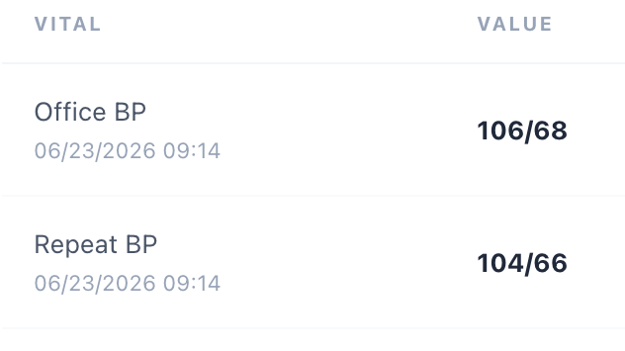
Evidence A — Detailed Vitals: 06/23/2026 09:14 beside BP 106/68 (and repeat BP 104/66).
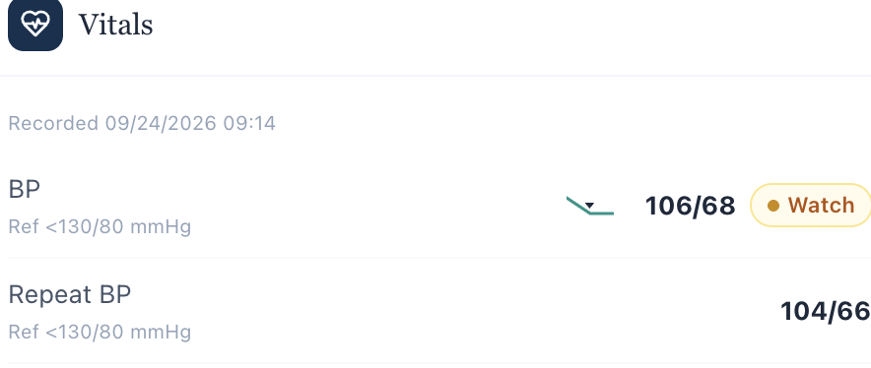
Evidence B — Follow-up Vitals: “Recorded 09/24/2026 09:14” with BP 106/68 and repeat BP 104/66.

MT-WED-02 | Body surface area does not match inputs
Priority MEDIUM Status Still needs developer action Type Internal EMR calculation inconsistency
Problem. The Vitals table labels the BSA calculation “Mosteller” but displays a result inconsistent with the weight and height shown in that same table.
What the student sees. Weight 101 kg, height 5 ft 10 in (177.8 cm), BSA (Mosteller) 2.04 m².
Expected calculation. Mosteller BSA = √[(height in cm × weight in kg) / 3,600] = √[(177.8 × 101) / 3,600] ≈ 2.23 m², not 2.04 m².
Why this matters. Incorrect body surface area may affect clinical calculations and could lead students to use an inconsistent objective value. No medication-dose error is shown for this encounter.
Please fix. Review the displayed inputs, calculation, and BSA output. Recompute the Mosteller value using the actual recorded height and weight, or correct any mislabeled source measurement.

Evidence — original Wednesday browser screenshot
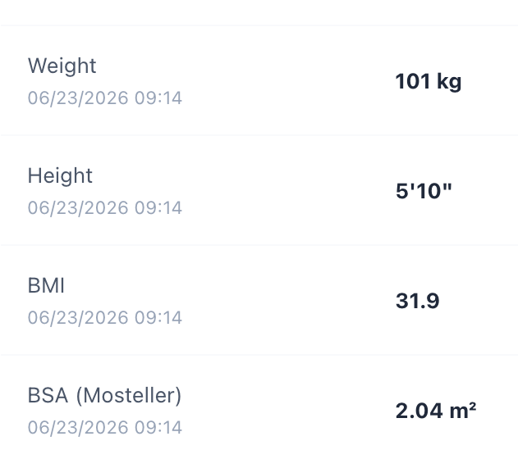
Evidence C — Detailed Vitals shows 101 kg, 5 ft 10 in, and “BSA (Mosteller) 2.04 m²” together.
Closeout: The Wednesday AI grader awarded 100%. These two findings concern live EMR data consistency rather than SOAP-documentation quality or scoring.
Michael Thompson (MT) / Patient A

Thursday — 6-Month Follow-Up
AI-grader result: 97.1% (Strong) | Visible deductions: 8 / −3.0 pts
Undocumented spironolactone addition timing; missing room-air source; conflation of BNP with NT-proBNP; other note refinements.
Primary evidence: MT Thur Initial Report.docx (user-provided individual report with its original grader / interview / EMR-source descriptions).
Michael Thompson (MT) | Thursday, 6-Month Routine Follow-Up

Audit outcome
AI grading outcome | Potential grading defects | Documentation-only deductions
97.1% — Strong; 8 visible deductions = 3.0 rubric points | 3 distinct concerns; 4 rubric entries, 1.4 points | 4 rubric entries; 1.6 points

Purpose. Compare the student-facing Thursday EMR export, actual AI-patient interview, reference checklist, and complete grader feedback. Identify actionable scoring mismatches without converting rubric expectations into unsupported clinical facts.
Feedback completeness. Three feedback screenshots supplied; user confirmed there are no additional items below criterion 3C.8. The grader narrative praises comprehensive clinical documentation; the eight deductions are listed in the detailed scoring panel.

Summary of developer-review findings
ID | Finding | Rubric impact | Status
MT-THU-01 | Unsupported “most recent spironolactone addition” requirement | −0.9 (two items) | Open — source/timeline review
MT-THU-02 | Room-air qualifier required without documentation | −0.2 | Open — source review
MT-THU-03 | BNP and NT-proBNP treated as one numeric trend | −0.3 | Open — clinical grading logic

What is not counted as a defect
Four additional deductions (BMI source-linking −0.3; agent-specific BP wording −0.5; statin assessment language −0.3; and cardiovascular-risk context −0.5) concern note specificity. These are coaching items, not verified AI/EMR bugs. No patient-interview contradiction is established.

Evidence and disposition rules
Original grader-feedback screenshots are cropped for readability and placed under each relevant finding. EMR and medication values cited from the supplied DOCX exports are identified as documentary evidence, not mislabeled as original live-browser screenshots. Thursday vital-display/calculation observations remain pending direct live-screen confirmation.
MT-THU-01 • DEVELOPER REVIEW

Spironolactone “most recent addition” is not established by visit history
Priority: High Impact: −0.5 (1A.9) + −0.4 (3A.19) = −0.9 points Type: Rubric-vs-clinical-history mismatch
Problem. The grader deducts twice because the SOAP does not assert spironolactone was the most recently added GDMT agent “since the prior visit.” The actual available visit history does not establish that ordering.
What the record supports. Wednesday’s EMR already lists spironolactone 25 mg PO daily as active; the Wednesday interview independently confirms use at that visit. Thursday lists the same medication and dose. Neither file provides a verified start date or ordering among GDMT additions.
What the grader expects. Rubric 1A.9 and 3A.19 each require the unsupported statement that spironolactone was the most recent addition. The SOAP appropriately said the exact addition date had not been established.
Why this matters. The scoring rule encourages students to invent a medication timeline, creating inaccurate medication reconciliation and undermining safe documentation.
Please fix. Remove “most recently added” as a required assertion unless the live encounter contains an explicit dated medication history; otherwise award full credit for accurately listing and continuing spironolactone. Avoid scoring the same unsupported premise in both subjective and assessment categories.

Evidence — original AI-grader feedback, focused crops
Figure 1A. Original MT Thur Feedback 03.png, criterion 1A.9 (−0.5 points).
Figure 1B. Same original feedback screenshot, criterion 3A.19 (−0.4 points).
Cross-check / source. MT Wed EMR 10-20.docx, “Current medications / prescribed active medications,” lists spironolactone 25 mg PO daily; MT Wed Interview 04.png confirms current use. MT Thur EMR 10-20.docx lists spironolactone 25 mg PO daily without a start date.
Retest acceptance. A clinically accurate SOAP that states spironolactone is continued at 25 mg PO daily, without inventing start order, receives the related rubric points when no verified addition date is shown.
MT-THU-02 • DEVELOPER REVIEW

Grader requires “room air” despite missing oxygen-delivery detail
Priority: Medium Impact: −0.2 points (2A.5) Type: Missing-source detail demanded by rubric
Problem. The SOAP documents SpO₂ 98% and explicitly avoids assuming supplemental-oxygen status. The grader deducts because it does not append “on room air.”
What the record supports. Thursday’s supplied EMR export displays “SpO₂ 98%” in its vital-sign sections without an explicit room-air or oxygen-delivery field. The interview does not establish whether the measurement was on room air.
What the grader expects. Criterion 2A.5 requires the statement “SpO₂ 98% on room air” as though the qualifier is documented.
Why this matters. Unknown oxygen delivery changes interpretation of the oxygen saturation; adding “room air” without a source would be an unsupported clinical assumption. This same requirement caused a Tuesday deduction in the earlier initial-visit audit.
Please fix. If oxygen-delivery status is not displayed anywhere accessible in the live encounter, accept accurate “SpO₂ 98%” documentation, with or without an “unknown/not documented” qualifier. If room air is intended, expose it in the EMR and rubric source material.

Evidence — original AI-grader feedback
Figure 2. Original MT Thur Feedback 03.png, criterion 2A.5 (−0.2 points).
Source limitation. The available Thursday EMR copy supports the SpO₂ number, but no separate full live-Vitals screenshot with delivery settings was provided. Confirm in the live UI before labeling this a fully proven interface omission.
Retest acceptance. The grader should not require undocumented oxygen-delivery status. If the room-air source is supplied, test both explicit room-air notation and a clinically equivalent accurate description.
MT-THU-03 • DEVELOPER REVIEW

Baseline BNP is incorrectly compared with later NT-proBNP
Priority: High Impact: −0.3 points (3A.6) Type: Biomarker clinical-scoring inconsistency
Problem. The grader deducts because the SOAP refuses to treat the baseline “320” and current “92” as a directly comparable assay trend, even though the laboratory names differ across visits.

What the available encounter data actually show
Encounter | Label in the supplied EMR | Value
Tuesday — initial | BNP | 320 pg/mL
Wednesday — 3 months | NT-proBNP | 165 pg/mL
Thursday — 6 months | NT-proBNP | 92 pg/mL

Correct interpretation. The documented Wednesday-to-Thursday NT-proBNP result decreases from 165 to 92 pg/mL, consistent with a favorable same-assay trend. A direct numeric “320 to 92 NT-proBNP” improvement cannot be claimed from the Tuesday BNP result. Clinical status and LVEF also improve, independently supporting treatment response.
What the grader expects. Criterion 3A.6 asks for a baseline-to-current BNP decrease of 320 to 92. The SOAP described the biomarkers separately and was penalized for clinical caution.
Please fix. Align the reference lab names with the student-facing results. Prefer awarding credit for a correct same-assay NT-proBNP 165 → 92 trend and an accurate note about the different baseline BNP assay. If a three-point NT-proBNP trend is intended, supply the corresponding initial NT-proBNP measurement.

Evidence — original AI-grader feedback
Figure 3. Original MT Thur Feedback 03.png, criterion 3A.6 (−0.3 points).
Cross-check / source. MT Tue EMR 10-16.docx “Cardiac Biomarkers”: BNP 320 pg/mL; MT Wed EMR 10-20.docx: NT-proBNP 165 pg/mL; MT Thur EMR 10-20.docx “Cardiac Biomarkers”: NT-proBNP 92 pg/mL. The Thursday trend narrative mislabels the 320 value as NT-proBNP.
Retest acceptance. A SOAP documenting NT-proBNP 165 → 92 and distinguishing the different BNP baseline must receive credit without being forced into an inaccurate three-point assay trend.
OTHER DEDUCTIONS • EMR OBSERVATIONS • FOLLOW-UP

Other deductions — documentation coaching, not filed as defects
Rubric | Points | Recommended SOAP improvement
2C.1 — BMI | −0.3 | Explicitly state that 97 kg and 70 in correspond to BMI ~30.7 kg/m².
3B.7 — BP therapy | −0.5 | Name sacubitril/valsartan and metoprolol succinate when relating BP 112/68 to current therapy.
3C.3 — Statin | −0.3 | Explicitly assess atorvastatin 40 mg as a suitable current CV-risk-reduction regimen.
3C.8 — CV context | −0.5 | Connect the statin rationale to the patient’s heart failure and CV risk profile.

Additional EMR observations — direct live confirmation pending
Potential EMR-A: Internal Vitals timestamps. The Thursday summary displays 12/24/2026 for BP 112/68 and other values; the detailed vitals table associates those same measurements with 06/23/2026. This is an internal timestamp discrepancy, not merely a simulated-calendar date issue. Capture side-by-side live Vitals summary and detailed table before filing.
Potential EMR-B: Mosteller BSA computation. The Thursday detailed Vitals table gives 97 kg, 5 ft 10 in (177.8 cm), and BSA 2.04 m². Mosteller calculation is approximately 2.19 m². Confirm the displayed input values and result in the live UI before classifying as a confirmed calculation defect.
Potential EMR-C: Laboratory collection metadata. Tuesday, Wednesday, and Thursday exports display some changed laboratory values with the same 06/09/2026 07:50 collection time. Verify their actual live-panel metadata; do not treat the shared timestamp by itself as proof of an underlying data defect.

Minimum evidence if retesting or escalating
Capture the Thursday live Vitals summary and detailed vitals/BSA table; verify whether oxygen-delivery status exists elsewhere in the live encounter; save dated medication-start history if available; capture original Tuesday BNP and Wednesday/Thursday NT-proBNP laboratory labels alongside the Thursday trend text. Do not retest the full interview unless a developer change directly affects patient-answer behavior.

Disposition summary
Open: 3 distinct AI-grader/reference concerns (4 deductions totaling 1.4 rubric points). Documentation-only: 4 deductions totaling 1.6 points. Pending live confirmation: 3 separately observed EMR export anomalies. No unsupported clinical information should be added merely to satisfy the reference checklist.
EMR — electronic medical record; GDMT — guideline-directed medical therapy; HFimpEF — heart failure with improved ejection fraction; ARNI — angiotensin receptor–neprilysin inhibitor; MRA — mineralocorticoid receptor antagonist; BNP and NT-proBNP — distinct natriuretic-peptide assays; SpO₂ — oxygen saturation; BSA — body surface area; SOAP — subjective, objective, assessment, plan.

Patient B — Angela Brooks (AB)

Tuesday — Initial Visit
AI-grader result: 99.3% (Strong) | Visible deductions: 3 / −0.8 pts
Unsupported room-air expectation and potential localized adherence-priority wording; renal/hepatic interpretation coaching.
Primary evidence: AB Tue Initial Report.docx (user-provided individual report with its original grader / interview / EMR-source descriptions).

Audit outcome
AI-grader | Visible deductions | Potential scoring concerns | EMR data observations
99.3% · Strong | 3 items · 0.8 rubric points | 2 distinct items for review | 2 discrepancies to verify

Executive summary. The submitted SOAP received strong feedback for accurate clinical history, medication reconciliation, risk assessment, and a comprehensive plan for cost-related apixaban and sacubitril/valsartan nonadherence. Three discrete deductions were shown in the complete uploaded feedback. One strongly suggests an unsupported source-data requirement; a second may reflect overly narrow recognition of adherence priorities. The remaining deduction is documentation coaching, not a defect.
Clinical context. Angela has persistent nonvalvular AFib (CHA₂DS₂-VASc 3), HFrEF (LVEF 35%), and financially driven omissions of apixaban and sacubitril/valsartan approximately 2–3 times per week. Her actual interview confirms her last apixaban dose was taken that morning, but remaining supply through her next refill was uncertain. The SOAP prioritizes restoring access and adherence without premature HFrEF escalation.

Findings at a glance
ID | Issue / interpretation | Score effect | Disposition
AB-TUE-01 | Room-air status demanded though not documented in supplied EMR | −0.3 pts | Developer review; likely source/rubric mismatch
AB-TUE-02 | Adherence priority appears elsewhere in note, but scorer requires more local phrasing | −0.3 pts | Developer review; possible scoring locality
Coaching | Renal and hepatic safety interpretation not jointly linked | −0.2 pts | Documentation improvement; not filed as defect
AB-TUE-E1/E2 | Vitals timestamps differ; Mosteller BSA inconsistent with inputs | No score effect shown | EMR-export concerns; verify in live UI

Evidence policy
Grader images are unmodified focused crops of AB Tue Feedback 02.png. The vital-sign excerpts on later pages are crops from the supplied AB Tuesday EMR DOCX export as rendered, not independently captured live-browser screenshots. The EMR findings should be confirmed in the live interface before being filed as verified UI defects. The reference checklist defines expected coverage; it is not independent proof of clinical facts.
AB-TUE-01 • DEVELOPER REVIEW • −0.3 PTS

Room-air status is required without a documented source
Problem. The student’s Objective section reported SpO₂ 98% and explicitly stated that oxygen-delivery status was not documented. Criterion 2A.6 penalizes the absence of a “room air” qualifier despite the available Tuesday EMR export showing SpO₂ 98% without a specific delivery-status field.
What the evidence supports. The Tuesday key Vitals and detailed Vitals list oxygen saturation as 98%. Neither excerpt identifies whether supplemental oxygen was in use. No interview answer establishes room-air status.
Why this matters. Filling missing information with an assumption is not accurate clinical documentation. Oxygen status can influence how saturation should be interpreted.
Recommended correction. Grade the accurate documented value “SpO₂ 98%” as sufficient when delivery status is not available to the learner; optionally award credit for appropriately noting that oxygen status is unspecified. Require “on room air” only when that status is explicitly supplied.

Evidence — original AI-grader deduction
Figure 1. AB Tue Feedback 02.png, criterion 2A.6 (−0.3 points).

EMR-export cross-check
Figure 2. AB Tuesday EMR export, detailed Vitals, SpO₂ field. No oxygen-delivery qualifier is displayed in this excerpt.
Retest criterion. Score a clinically faithful note that reports the saturation without assuming an unsupported oxygen-delivery mode. Confirm all accessible oxygen fields in the live UI before closing the issue.
AB-TUE-02 • DEVELOPER REVIEW (TENTATIVE) • −0.3 PTS

Adherence-improvement priority may be missed across SOAP sections
Problem. Criterion 3B.13 deducts because the AFib assessment identifies “access intervention and education” as immediate priorities without also stating “adherence improvement” as a third explicit phrase in that same context.
What the SOAP actually states. The HFrEF assessment calls for “cost, adherence, and education barriers” to be resolved. The cost-related nonadherence assessment identifies the major medication-therapy problem. The Plan includes restoring uninterrupted apixaban access, improving medication adherence, monitoring missed doses, and reassessing adherence at follow-up.
What remains ambiguous. The criterion may intentionally require adherence improvement named within the AFib problem statement. Without the grader’s scoring scope, it is not possible to prove the deduction is erroneous; this is a review candidate, not a verified software bug.
Recommended correction. Review whether clinically equivalent statements across the Assessment and Plan should satisfy criterion 3B.13. If a localized statement is mandatory, make that requirement clear in the checklist. A simple phrasing fix for the learner would be “Immediate priorities are adherence improvement and patient education, supported by medication-access intervention.”

Evidence — original AI-grader deduction
Figure 3. AB Tue Feedback 02.png, criterion 3B.13 (−0.3 points).
Retest criterion. A note that expressly prioritizes adherence improvement across an adjacent assessment and the linked care plan should be evaluated against the criterion’s intended cross-section scope, rather than exact phrase matching alone.

Not filed as a defect: documentation specificity
Criterion 2C.5 (−0.2). The SOAP states that eGFR 72 mL/min/1.73 m² supports current treatment and separately documents AST 24 U/L and ALT 21 U/L as normal. The grader seeks one explicitly integrated statement tying renal AND hepatic function to regimen continuation. This is a fair specificity improvement, not enough evidence of an AI grading defect.
Figure 4. AB Tue Feedback 02.png, criterion 2C.5 (−0.2 points).
Suggested documentation: “Renal function (SCr 1.0 mg/dL, eGFR 72 mL/min/1.73 m²) and hepatic enzymes (AST 24 U/L, ALT 21 U/L) support continued use of the current medications, with routine monitoring.”
ADDITIONAL OBSERVATIONS • NOT YET LIVE-UI CONFIRMED

Potential EMR-E1 — Inconsistent recording dates on identical vital signs
What the EMR export shows. The initial-visit “Key vitals” section associates BP 128/78 mmHg and repeat BP 126/76 mmHg with 09/09/2026 09:14. The detailed “Vitals” section gives the same values with 06/23/2026 09:14.
Why review. It is unclear whether these are two distinct encounters with identical measurements or the same measurements assigned conflicting dates. If they represent the same recorded readings, the display should reconcile the timestamp or label historic data.
Action. Compare the two panels in the live AB Tuesday encounter, including underlying encounter ID and collection time. If the values are identical copies of the same observation, correct date synchronization or explicitly label prior measurements.

Evidence excerpts — supplied EMR export
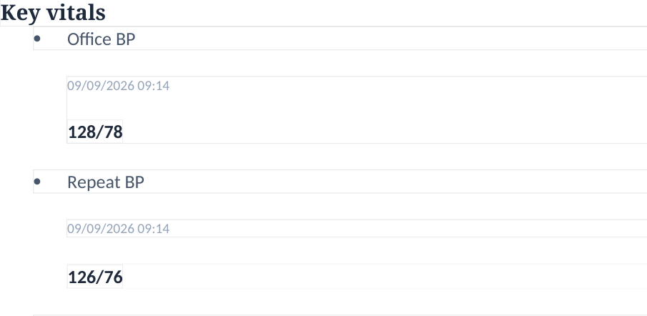
Figure 5A. AB Tuesday EMR export, Key Vitals: BP 128/78, repeat 126/76 under 09/09/2026.
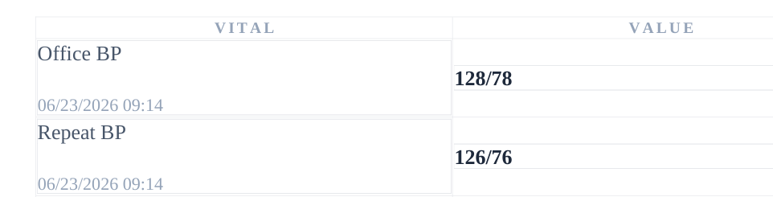
Figure 5B. Same EMR export, Detailed Vitals: BP 128/78, repeat 126/76 under 06/23/2026.
ADDITIONAL OBSERVATIONS • NOT YET LIVE-UI CONFIRMED

Potential EMR-E2 — Mosteller BSA does not match displayed measurements
What the EMR export shows. The detailed Vitals table records weight 84 kg, height 5 ft 5 in (165.1 cm), and BSA (Mosteller) 2.04 m².
Expected calculation. Mosteller BSA = √[(165.1 cm × 84 kg) / 3,600] = 1.963 m², or approximately 1.96 m². The displayed 2.04 m² is not consistent with the stated formula and visible inputs.
Action. Confirm in the live Vitals table, then inspect the application’s BSA formula, the underlying units, and any cached height/weight source. Recalculate or relabel the result rather than relying on the inconsistent number.

Evidence — supplied EMR export
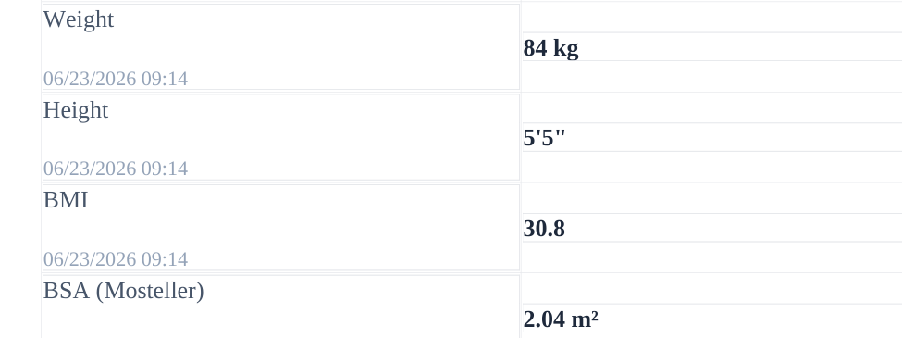
Figure 6. Detailed Vitals excerpt displaying weight, height, BMI, and BSA (Mosteller) 2.04 m².

Disposition and evidence requests
Area | Current determination | Next step
AI-grader | 99.3% (Strong), 3 deductions | Review AB-TUE-01 and potentially AB-TUE-02; coach 2C.5
Student-facing EMR | Two inconsistencies visible in the supplied export | Confirm dates and BSA in the live Tuesday encounter
AI-patient responses | No established interview-versus-EMR discrepancy | Preserve original interview screenshots; no repeat questions needed
Evidence completeness | Both submitted grader screenshots reviewed | No further deductions visible in supplied screenshot; reconfirm if panel has additional hidden content

Minimum additional evidence. Two live Vitals screenshots (Key Vitals date/BP and Detailed Vitals date/BP/BSA) would upgrade the two export-based observations to direct live-screen evidence. If present elsewhere, capture any oxygen-delivery field to resolve AB-TUE-01.
Angela Brooks (AB) / Patient B

Wednesday — 3-Month Follow-Up
AI-grader result: 97.6% (Strong) | Visible deductions: 7 / −2.4 pts
Room-air requirement, HF stability erroneously linked to apixaban interruption, and possible overstatement of AF knowledge deficit.
Primary evidence: AB Wed Initial Report.docx (user-provided individual report with its original grader / interview / EMR-source descriptions).

Audit outcome
Executive summary. Angela's follow-up SOAP note received 97.6% (Strong). The complete grader feedback shows seven deductions totaling 2.4 rubric points. Three deserve developer review, while four are primarily reasonable improvements in wording, structure, or lab annotation. No demonstrated AI-patient-versus-EMR contradiction was found in the interview.
Clinical context. The patient independently stopped apixaban 5 mg twice daily several weeks earlier after self-limited bruising. Her CHA2DS2-VASc score is 3; she reports no major bleeding symptoms or stroke warning signs. Cost barriers improved through an assistance program, and HFrEF symptoms remained stable on three prescribed GDMT classes. The audit concerns scoring and source consistency - it is not a record of treatment delivered.
AI-grader | Visible deductions | Developer-review items | Documentation items
97.6% | Strong | 7 criteria | -2.4 pts | 3 distinct grading concerns | 4 writing/refinement deductions

Findings at a glance
ID | Issue | Effect | Disposition
AB-WED-01 | Undocumented room-air qualifier required (2A.6) | -0.3 | Potential rubric/source mismatch
AB-WED-02 | HF stability tied to apixaban interruption (3A.17) | -0.3 | Potential clinical-relevance mismatch
AB-WED-03 | Broad AF knowledge gap required (3C.2) | -0.3 | Potential overgeneralization
Other 4 | CMP summary; bruising attribution; SOAP placement; lab context | -1.5 | Documentation improvements

Evidence standard
The grading findings use focused crops of the original AB Wed Feedback 03.png. EMR screenshots below were obtained by rendering the supplied "AB Wed EMR 10-20.docx" export; they are not independent live-UI screenshots. The interview is the source for actual patient statements. The checklist is a reference, not proof of clinical facts. EMR anomalies are flagged for live-system verification before developer defect classification.
AB-WED-01 | DEVELOPER REVIEW | -0.3 PTS

Required room-air qualifier is absent from the available EMR
Rubric item. 2A.6. The grader deducts credit because SpO2 98% was not explicitly documented as "on room air." The student instead noted that oxygen-delivery status was not documented.
Evidence-based interpretation. The Wednesday Vitals and detailed Vitals displays report SpO2 98%, with no room-air or supplemental oxygen status shown in those fields. The interview does not establish oxygen delivery.
Developer recommendation. Allow a faithful "SpO2 98%" entry when oxygen modality is unavailable; reward explicit uncertainty rather than requesting an undocumented fact. Check all live oxygen fields before closing the issue.

Evidence - exact grader deduction
Original feedback screenshot, AB Wed Feedback 03.png, 2A.6.
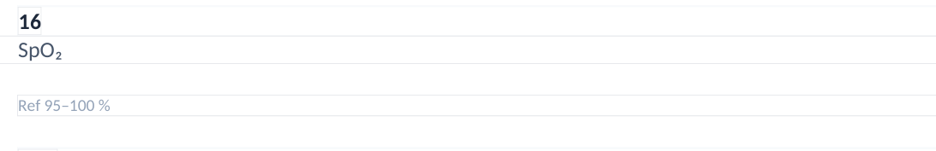
EMR export, page 6, Objective Vitals: SpO2 98%; room-air status not displayed.
AB-WED-02 | DEVELOPER REVIEW (TENTATIVE) | -0.3 PTS

HF stability criterion references an unrelated apixaban interruption
Rubric item. 3A.17. The grader expects an explicit link between clinically stable HFrEF and several weeks without apixaban.
Evidence-based interpretation. Apixaban is being used for AF-related stroke prevention, not HFrEF disease modification. The SOAP correctly documented unchanged dyspnea/fatigue, no congestion, and improved adherence to ARNI, beta blocker, and SGLT2 inhibitor. One may document that both conditions coexisted, but this is not evidence that anticoagulation interruption preserves HF stability or is safe.
Developer recommendation. Review whether this cross-problem linkage adds clinically meaningful information. Accept independent, well-supported HFrEF and anticoagulation assessments; do not require causal inference from absence of HF decompensation.

Evidence - exact grader deduction
Original feedback screenshot, AB Wed Feedback 03.png, 3A.17.
AB-WED-03 | DEVELOPER REVIEW (TENTATIVE) | -0.3 PTS

Broad atrial-fibrillation knowledge deficit may exceed interview evidence
Rubric item. 3C.2. The grader requires a general knowledge gap about atrial fibrillation, rather than accepting precise knowledge gaps about stroke-risk magnitude and bruising-versus-major-bleeding.
Evidence-based interpretation. Angela states she knows apixaban helps prevent an AF-related stroke; she remains unsure of her untreated stroke-risk magnitude and how to distinguish bruising from serious bleeding. These narrower deficits caused her decision to stop therapy. A broad claim of limited AF understanding was not separately established.
Developer recommendation. Award credit for supported, patient-specific knowledge gaps, or explicitly require a separate question establishing general AF understanding before asking for that assertion.

Evidence - exact grader deduction
Original feedback screenshot, AB Wed Feedback 03.png, 3C.2.

Other four deductions - SOAP improvement opportunities
Criterion | Points | Reasonable revision
2C.4 | -0.3 | Add concise "CMP otherwise unremarkable" summary if supported by all available results.
3A.5 | -0.4 | Name the likely minor anticoagulation-associated nature of bruising; distinguish it from major bleeding.
5A.4 | -0.5 | Keep objective raw data separate from interpretations of hemoglobin, anticoagulant dosing, and stroke risk.
5B.2 | -0.3 | Add normal/abnormal reference or trend qualifiers for BUN, WBC, AST, ALT, and other reported labs.

These four deductions concern note specificity and format; they should not be counted as confirmed application defects. Together, they account for 1.5 of the 2.4 deducted rubric points.

Evidence - four documentation deductions
Original feedback screenshot, AB Wed Feedback 03.png, Criterion 2C.4.
Original feedback screenshot, AB Wed Feedback 03.png, Criterion 3A.5.
Original feedback screenshot, AB Wed Feedback 03.png, Criterion 5A.4.
Original feedback screenshot, AB Wed Feedback 03.png, Criterion 5B.2.

Separate EMR-export quality observations
The following findings were derived from the supplied Wednesday EMR export and were not among the seven grader deductions. They should be checked in the live application before being labeled confirmed developer defects.
Observation | Evidence | Suggested QA action
Conflicting vital dates | Summary: 12/09/2026 09:14; detailed Vitals: 06/23/2026 09:14 for matching BP, HR, SpO2. | Confirm historical/current timestamps and label carried-forward values.
Mosteller BSA inconsistent | EMR: 84 kg, 5 ft 5 in, BSA 2.04 m2. Mosteller calculation approximately 1.96 m2. | Verify inputs and BSA formula/field mapping.
Wrong intake label | Follow-up encounter includes "Initial Ambulatory Care Pharmacist Visit" in subjective intake metadata. | Distinguish copy-forward metadata from the current visit.
Different peptide assays | Tuesday chart labels 210 pg/mL as BNP; Wednesday chart labels 210 pg/mL as NT-proBNP. | Verify assay/source mapping; avoid treating as directly comparable trend.
Lab timestamp reuse | Some Wednesday results carry 06/09/2026 laboratory collection date. | Check whether these are intentionally prior labs vs current values.

Priority clinical-content issue - unsafe certainty about bleeding
Source wording. The EMR counseling script says a stable hemoglobin of 13.0 g/dL "proves" that no internal bleeding is occurring. A stable Hgb (13.2 to 13.0 g/dL) and absence of reported warning signs are reassuring but do not, by themselves, exclude occult bleeding.
Recommended fix. Revise the script to describe the laboratory data as reassuring rather than definitive; counsel on major bleeding warning signs, clinical assessment, and prompt review before any apixaban restart after an interruption.
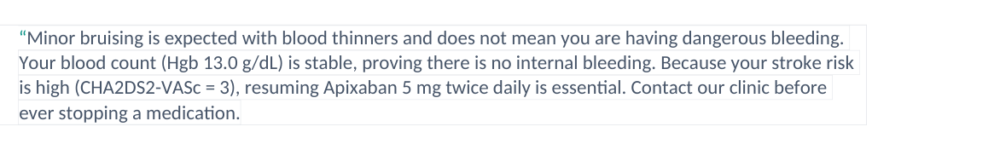
EMR export, page 11, student-facing counseling script with the categorical Hgb claim.

Focused EMR-export screenshots

A. Summary vs detailed vital-sign timestamps
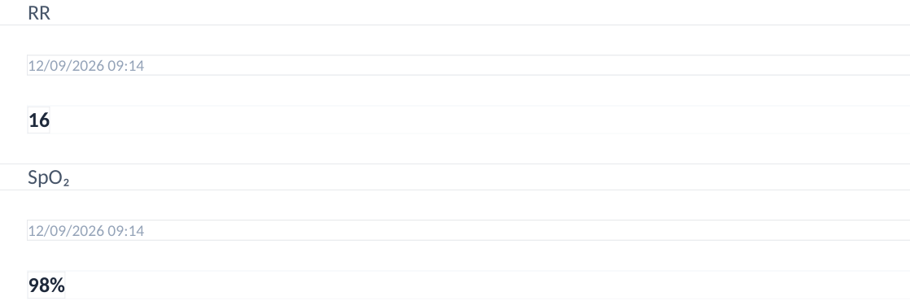
EMR export, page 2, summary Vitals: dated 12/09/2026; SpO2 98%.
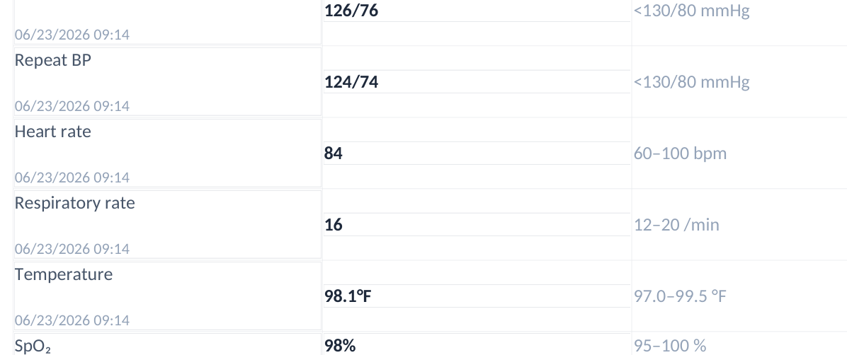
EMR export, page 8, detailed Vitals: dated 06/23/2026 for the same clinical measurements.

B. Mosteller BSA field
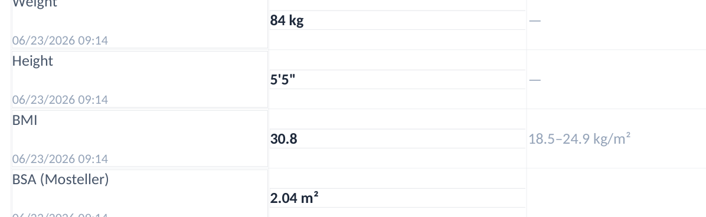
EMR export, page 9: 84 kg, 5 ft 5 in, calculated field displayed as 2.04 m2.
Calculation. Mosteller BSA = sqrt[(height in cm x weight in kg)/3600] = sqrt[(165.1 x 84)/3600] = 1.963 m2 (approximately 1.96 m2). The export value is about 0.08 m2 higher. Recorded BMI 30.8 kg/m2 is consistent with the reported height and weight.

C. Misleading encounter-type metadata

EMR export, page 4, intake attribution labeled "Initial Ambulatory Care Pharmacist Visit" within Wednesday follow-up record.

Developer action list & evidence inventory
Priority | Recommended check | Expected behavior
1 | Review 2A.6 oxygen-status rubric vs accessible live EMR. | No penalty for accurate SpO2 without unavailable room-air qualifier.
2 | Examine 3A.17 HF/anticoag linkage criterion. | HF assessment based on HF data, not inferred anticoagulant effect.
3 | Check 3C.2 for broad versus specific patient knowledge documentation. | Accept directly evidenced knowledge deficits and accurately qualified uncertainty.
4 | Validate EMR dates/BSA, intake metadata, and BNP-vs-NT-proBNP labels. | Consistent, explicit, auditable source data.
5 | Amend hemoglobin counseling language. | Stable CBC treated as supportive, not exclusionary proof of no occult bleed.

Materials reviewed
• AB Wed EMR 10-20.docx (11-page supplied EMR export)
• AB Wed Interview 01.png through 09.png; two additional anticoagulation safety-response screenshots
• Pasted text(4).txt (Wednesday Grading Checklist - reference only)
• AB Wed Feedback 01.png through 03.png (score, narrative feedback, all seven deductions)
• AB Tue EMR 10-20(1).docx (baseline label of BNP where a cross-visit comparison was made)

Verification & limitations
AI-grader deductions were transcribed from the complete submitted feedback screenshots. Screenshot excerpts were cropped only to focus existing source content, without inserting or fabricating source text. Live-EMR issues remain provisional because the document is a supplied export. No patient identity or score was inferred from the rubric alone; no application code or internal grading implementation was available for testing.
All findings are intended for developer QA review and evidence-based course audit, not a substitute for patient-specific medical decisions. A prescriber should reassess anticoagulation safety and promptly address the reported several-week apixaban interruption.
Angela Brooks (AB) / Patient B

Thursday — 6-Month Follow-Up
AI-grader result: 96.6% (Strong) | Visible deductions: 9 / −3.4 pts
Vaccines documented as administered were graded as pending; oxygen-status ambiguity; potential overly literal adherence linkages.
Primary evidence: AB Thur Initial Report.docx (user-provided individual report with its original grader / interview / EMR-source descriptions).

Audit outcome
Executive summary. The AB Thursday SOAP earned 96.6% (Strong). Nine visible deductions total 3.4 rubric points. Six criteria (2.7 points) warrant developer review, of which three (1.4 points) directly contradict the EMR and patient-reported vaccination events. The remaining three (0.7 points) are primarily documentation-specific coaching items.
Clinical context. The 64-year-old patient reports 100% adherence to apixaban 5 mg twice daily and three HFrEF GDMT agents after assistance-program enrollment and pharmacist counseling. Prior bruising fears have resolved; the patient reports stable HF symptoms and requests clarification about the duration of long-term therapy. The EMR documents pneumococcal completion and same-day Shingrix dose #2 plus Tdap administration.
AI-grader | Visible deductions | Developer-review criteria | Documentation refinements
96.6% / Strong | 9 criteria / -3.4 points | 6 criteria / -2.7 points | 3 criteria / -0.7 points

Findings at a glance
ID | Primary issue | Effect | Disposition
AB-THU-01 | Shingrix #2 recorded today but graded as pending (3E.3) | -0.5 | Direct rubric/source contradiction
AB-THU-02 | Tdap administered today but graded as remaining gap (3E.4) | -0.5 | Direct rubric/source contradiction
AB-THU-03 | Tdap given today but scorer expects future plan (3E.5) | -0.4 | Direct rubric/source contradiction
AB-THU-04 | SpO2 on room air required but not established (2A.7) | -0.3 | Recurring potential data/rubric mismatch
AB-THU-05 | Medication access -> adherence linkage (3C.5) | -0.5 | Potential overly literal semantic scoring
AB-THU-06 | Education/confidence -> adherence linkage (3D.6) | -0.5 | Potential overly literal semantic scoring
Coaching | HR, statin rationale, and renal monitoring specificity | -0.7 | Reasonable documentation improvements

Evidence standard
The feedback screenshots are the direct grading source. The EMR image excerpts are generated by rendering the supplied AB Thur EMR 10-20.docx export, not independent live-app screenshots. Patient interview screenshots support reported vaccine receipt, restored adherence, and safety understanding. No checklist-only fact is treated as a confirmed patient event.

Priority developer findings - vaccination contradictions
The feedback itself is internally inconsistent: Strengths praise accurate same-day Shingrix #2 and Tdap documentation; Opportunities to Improve instructs the student to avoid calling those vaccines pending; three explicit deductions nevertheless require pending or future-vaccine language.
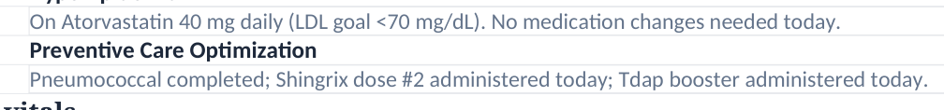
EMR export, page 1: active Preventive Care problem states Shingrix dose #2 and Tdap booster administered today.
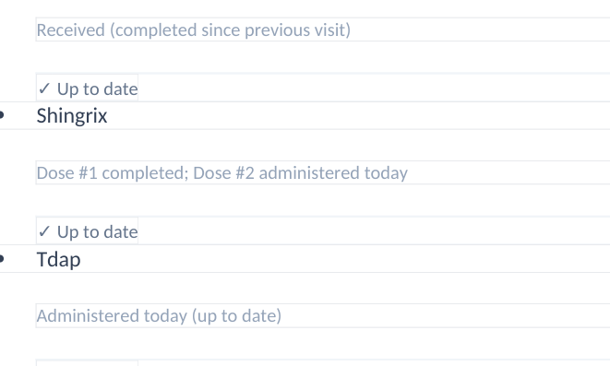
EMR export, page 7: immunizations list Shingrix dose #2 and Tdap as administered today.
AI-grader feedback 03: all three vaccine-related deductions (3E.3, 3E.4, 3E.5).
AB-THU-01 | DEVELOPER REVIEW | -0.5 POINTS

Shingrix dose #2 erroneously required to remain pending
Rubric/scorer: 3E.3 penalizes documentation of completed second dose rather than "Dose 1 completed; dose 2 pending".
Interpretation: Both EMR and patient interview support dose #2 administered at the Thursday encounter. The SOAP documented a completed series and advised verification of the administration record.
Recommended developer action: Update rubric to accept documented same-day series completion, distinguishing pre-visit status from current/post-visit status. Do not require fictitious pending documentation.
AB-THU-02 | DEVELOPER REVIEW | -0.5 POINTS

Tdap incorrectly required as a current care gap
Rubric/scorer: 3E.4 expects the booster to be "remaining" or due.
Interpretation: EMR states Tdap administered today; patient confirms receipt. It was a prior gap that was addressed during this visit.
Recommended developer action: Recognize documentation of gap closure; allow explicit "due before visit; given today" chronology but do not penalize truthful administration documentation.
AB-THU-03 | DEVELOPER REVIEW | -0.4 POINTS

Future Tdap plan required despite same-day administration
Rubric/scorer: 3E.5 deducts credit because Tdap was given at this visit rather than planned for a future visit.
Interpretation: A plan to administer another booster at a later appointment would be an inappropriate duplicate if the current documented dose is confirmed.
Recommended developer action: Treat completed intervention as satisfying or superseding the prospective-plan criterion. Reconcile checklist and same-day immunization data.

Other potential grading issues
AB-THU-04 | DEVELOPER REVIEW | -0.3 POINTS

Unverified room-air qualifier required for SpO2
Rubric/scorer: 2A.7 deducts 0.3 because the note says SpO2 98% with oxygen delivery status not documented rather than "on room air".
Interpretation: Thursday structured and detailed EMR views show SpO2 98%, but the available export does not establish room-air status. Tuesday and Wednesday had analogous deductions.
Recommended developer action: Accept faithful SpO2 documentation with an explicit unknown oxygen-delivery qualifier; inspect all live EMR oxygen fields before final defect determination.
AB-THU-05 | DEVELOPER REVIEW | -0.5 POINTS

Adherence improvement linkage graded too locally
Rubric/scorer: 3C.5 says improved medication affordability/transportation was not explicitly linked to restored adherence.
Interpretation: The SOAP describes cost-related nonadherence previously, identifies assistance enrollment and improved pharmacy access as resolving barriers, and reports subsequent 100% adherence. A direct single-sentence causal statement would help, but the relationship appears supported across sections.
Recommended developer action: Check semantic grading across the full note rather than exact wording in one Assessment subsection; accept clinically equivalent causal documentation.
AB-THU-06 | DEVELOPER REVIEW | -0.5 POINTS

Counseling-driven adherence improvement may be undercredited
Rubric/scorer: 3D.6 says improved health literacy/confidence was not explicitly linked to improved adherence.
Interpretation: The SOAP states prior anticoagulation education resolved bleeding fears, strengthened understanding, and supported consistent medication use. The source interview explicitly attributes improved adherence to counseling.
Recommended developer action: Accept cross-sentence or cross-section relationships where supported by actual patient statements. This remains a tentative scoring concern rather than a proven model failure.
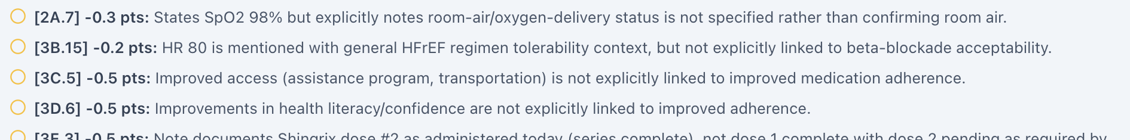
AI-grader feedback 03: room-air criterion plus the access/education linkage deductions.
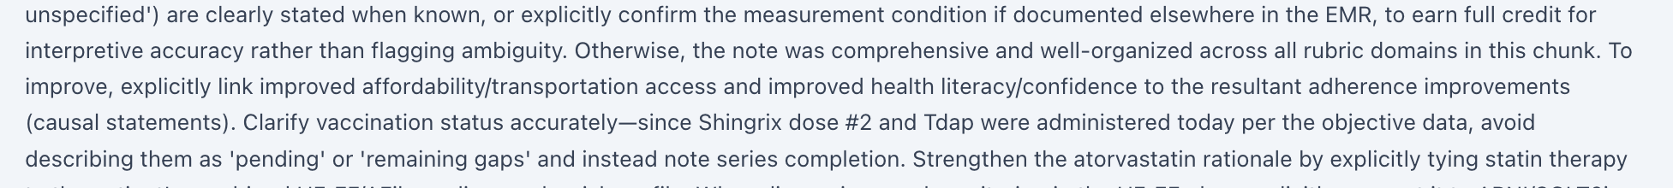
AI-grader feedback 02: opportunities section simultaneously recognizes vaccines administered today and requests clearer causal linkage.

Other three deductions - reasonable SOAP refinements
Criterion | Points | Practical note revision
3B.15 | -0.2 | Explicitly link HR 80 bpm and BP 124/74 mmHg to current beta-blocker tolerability in HFrEF assessment.
3F.4 | -0.3 | Tie atorvastatin to aggregate cardiovascular-risk management in the patient with HFrEF/AFib comorbidities; do not imply statins specifically treat AFib.
4B.11 | -0.2 | State that routine SCr/eGFR monitoring evaluates ARNI and SGLT2 inhibitor safety, rather than naming renal monitoring only generically.

AI-grader feedback 03: statin rationale and ARNI/SGLT2 monitoring deductions; HR criterion appears in the earlier feedback excerpt.

Separate EMR-export data-quality observations
The following are internal inconsistencies in the Thursday EMR export, distinct from the nine grader deductions. They should be verified in the live application before classifying them as confirmed UI, data-mapping, or calculation defects.
Observation | EMR evidence | Suggested QA test
Dates | Summary vitals 03/09/2027 09:14; detailed Vitals 06/23/2026 09:14 for matching numbers. | Inspect source event IDs, encounter date, and data provenance.
Weight/BMI | Structured: 84 kg / BMI 30.8; supplemental: 83 kg / BMI 30.5. | Identify current vs imported measurements; label source/timestamp.
Lab mismatch | Structured: Na 139, AST 24, ALT 21, platelets 241; supplemental: Na 138, AST 22, ALT 24, platelets 240. | Reconcile lab date, assay and source/field mapping.
BSA | Mosteller shown as 2.04 m2 with height 5 ft 5 in and weight 84 kg. Calculated ~1.96 m2. | Recompute from recorded height and weight; check carry-forward.
Visit metadata | Six-month follow-up also marked "Initial Ambulatory Care Pharmacist Visit" in intake. | Check reusable template/copy-forward label.
Med rec status | Current medication list shows "Med rec: Pending" while 100% adherence is reported. | Determine whether medication reconciliation was formally completed; do not equate self-report with workflow closure.

Source images - key EMR inconsistencies
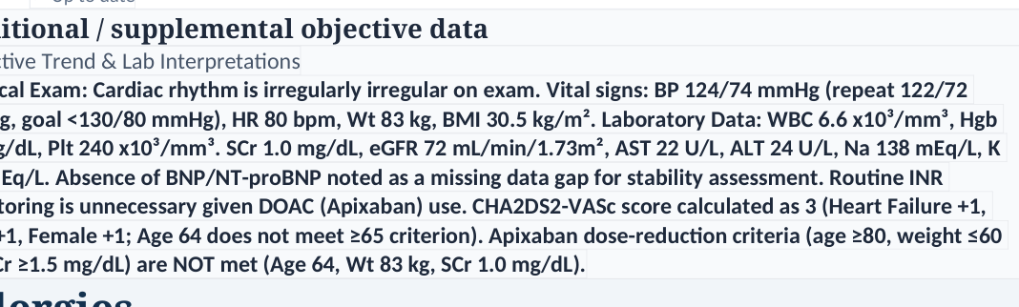
EMR export, page 7: supplemental Objective data use weight 83 kg/BMI 30.5 and alternate lab values.
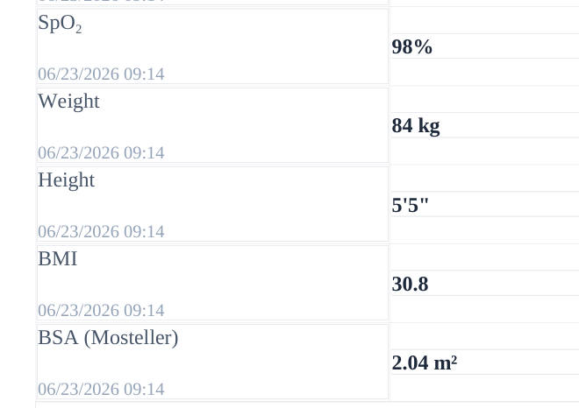
EMR export, page 8: structured vitals 84 kg, 5 ft 5 in, BMI 30.8 and BSA 2.04 m2.

Developer action list and evidence inventory
Priority | Developer verification/action | Expected behavior
1 | Resolve 3E.3 / 3E.4 / 3E.5 checklist versus EMR vaccination status. | A same-day documented dose closes the current gap and earns corresponding credit.
2 | Review recurrent 2A.7 room-air source availability across AB visits. | No penalty for unavailable/undocumented SpO2 context.
3 | Audit 3C.5 / 3D.6 semantic matching against full SOAP and interview. | Equivalent, patient-supported causality is credited across sections.
4 | Reconcile internal EMR timestamps, weight/BMI, lab values and BSA. | Displayed objective data agree or clearly show date/source distinctions.
5 | Check initial-visit intake label and "pending" med-rec workflow flag. | Encounter labels/statuses reflect underlying record accurately.

Materials reviewed
- AB Thur EMR 10-20.docx (10-page supplied EMR export); rendered excerpts explicitly labeled as export evidence.
- AB Thur Interview 01.png through 10.png and the supplemental bleeding/OTC interview screenshot supplied in the chat.
- Pasted text(5).txt (Thursday 6-month grading checklist; reference only).
- AB Thur Feedback 01.png through 03.png (96.6% score, strengths, opportunities, all nine deduction statements).
- AB Tuesday and Wednesday audit context (adherence and anticoagulation history only; not substituted for Thursday live responses).

Verification & limitations
Grader deductions were transcribed from the supplied feedback, whose visible items sum to 3.4 points. Cropped images are unmodified excerpts except for cropping to display relevant evidence. The student-facing EMR export has internal data conflicts, so the report does not silently choose an authoritative number for those discrepant fields. No independent live-UI confirmation or immunization registry proof was available; patient report and supplied EMR agree regarding the vaccinations. This is a developer-QA and educational audit, not a substitute for clinical decision-making.

Patient C — Robert Jenkins (RJ)

Tuesday — Initial Visit
AI-grader result: 99.0% (Strong) | Visible deductions: 4 / −1.0 pts
Peripheral versus lower-extremity edema phrase matching; spouse-specific concern and renal-protective framing gaps; provisional EMR anomalies.
Primary evidence: RJ Tue Initial Report.docx (user-provided individual report with its original grader / interview / EMR-source descriptions).

Audit outcome
Figure 1. Original AI-grader result: 99% (Strong).
Executive summary. RJ received 99% (Strong), with four explicitly itemized deductions totaling 1.0 point. The grader praised comprehensive documentation of cardiorenal risk, the renal trajectory, stable HFrEF on four-pillar GDMT, careful apixaban dosing, and patient/spouse involvement. Most deductions relate to wording specificity rather than clinical inaccuracies.
Audit classification. One phrase-matching concern (1B.13) deserves a grading-policy review; three deductions (1B.21, 4B.8, 4B.9) are supportable documentation improvements. No confirmed AI-patient–EMR disagreement is established by the nine interview screenshots. Separately, the exported EMR contains potentially consequential display/calculation and chronology issues needing confirmation in the live UI.

Itemized grader deductions
Criterion | Points | What the grader wanted | Audit disposition
1B.13 | −0.2 | Explicit "lower extremity" edema denial | REVIEW: clinically equivalent phrasing may suffice
1B.21 | −0.2 | Wife concerned medicines worsen kidneys | GAP: wife-specific causal concern omitted
4B.8 | −0.3 | BP goal named as kidney-protective | GAP: renal-protective rationale not explicit
4B.9 | −0.3 | Diabetes control named as kidney-protective | GAP: renal-protective rationale not explicit

Total visible deductions: 4 criteria, −1.0 point. No additional itemized deductions are shown in the supplied grader feedback.

Evidence handling
This review treats the live EMR export, the AI-patient interview, the master checklist, and AI-grader feedback as distinct sources. The EMR is used for charted values only; it cannot establish patient verbal statements unless the interview independently supports them. Findings drawn from a Word export are labeled provisional until live-screen verification. Embedded images are original uploaded interview/grader captures or faithful crops thereof.
GRADER FEEDBACK / 4 DEDUCTIONS / −1.0 POINT

Finding RJ-TUE-01 — Potential overly literal edema wording
Source: Grader 1B.13, −0.2. The note denies “peripheral/abdominal edema”; the grader seeks an explicit “lower extremity edema” phrase. Actual interview: RJ says no swelling in the legs, ankles, or abdomen. The EMR ROS also documents denial of lower-extremity edema.
Review question. Does “peripheral edema” reasonably satisfy the intended clinical negative, or is localization to the legs a required discrete documentation field? This is a borderline wording issue, not a confirmed grader defect.
Suggested retest: Score two clinically equivalent negative statements under 1B.13 (“no peripheral edema” and “no lower-extremity edema”) and document whether the rubric intentionally requires anatomical specificity.

Finding RJ-TUE-02 — Spousal concern not explicitly medication-specific
Source: Grader 1B.21, −0.2. The submitted note indicates RJ and his wife fear dialysis, but does not explicitly attribute his wife’s worry to potentially nephrotoxic effects of sacubitril/valsartan/spironolactone. The charted HPI states that the spouse shares the concern about medications worsening renal function. The patient interview confirms that RJ and his wife worry about declining renal values and dialysis, without independently stating her medication-specific reasoning.
Disposition: Supported precision gap. A rigorous SOAP should attribute the medicine-specific concern to “EMR-recorded spouse concern,” not imply the patient verbally confirmed this detail. Recommended wording: “Per chart history, spouse also worries the current medicines may worsen kidney function; interview confirms shared fear of dialysis.”

Finding RJ-TUE-03 — BP goal needs explicit renal-protective framing
Source: Grader 4B.8, −0.3. The SOAP includes BP goal <130/80 and antihypertensive/GDMT continuation, but does not explicitly state that BP control is intended to slow CKD progression. This is a legitimate opportunity to link diabetes/HTN management with renal outcomes.
Suggested addition: “Maintain individualized BP control as a kidney-protective strategy to limit CKD progression, while avoiding symptomatic hypotension.”

Finding RJ-TUE-04 — HbA1c management needs renal-protective framing
Source: Grader 4B.9, −0.3. The SOAP describes HbA1c 6.9% and diabetes management near individualized target but does not expressly connect glucose management to preservation of renal function. The criterion is reasonable as a documentation-specificity expectation.
Suggested addition: “Continue individualized diabetes control and renal-protective agents, including empagliflozin as tolerated, to reduce risk of further CKD progression.”

Original deduction evidence
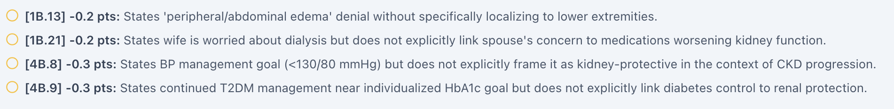
Figure 2. RJ Tue Feedback 02.png: four original criterion IDs and point deductions, cropped for readability.
EMR EXPORT QUALITY / PROVISIONAL FINDINGS / NOT SCORED BY GRADER

Potential EMR data-quality and logic problems
The following six observations are independent of the four AI-grader deductions. They originate in the supplied RJ Tuesday EMR DOCX export; the original live application and underlying source data must be checked before labeling them confirmed software defects.

EMR-E1 — eGFR 38 displayed as “Normal”
Evidence: The Key Labs panel and detailed BMP list eGFR 38 mL/min/1.73 m² followed by a “Normal” status, while CKD Stage 3b is correctly identified elsewhere in the record. An eGFR of 38 indicates significantly reduced kidney function and does not belong in a normal-status flag.
Developer action: Inspect reference range/status mapping and verify that units and CKD-stage interpretation feed the laboratory flag consistently. Risk: misleading clinician/student interpretation of renal impairment.

EMR-E2 — CKD labeled “Stable Longitudinal Trend” despite decline
Evidence: The problem-list title calls CKD Stage 3b a “Stable Longitudinal Trend,” yet its own narrative documents eGFR 52 → 46 → 38 mL/min/1.73 m² and SCr 1.42 → 1.58 → 1.82 mg/dL over 12 months. The time-series is not stable; stability of heart-failure symptoms should not overwrite renal trend interpretation.
Developer action: Revise the problem descriptor to distinguish “current CKD G3b” from “progressive decline over 12 months,” or document why the trend should be classified stable.

EMR-E3 — CHA2DS2-VASc score conflicts with documented factors
Evidence: The EMR lists CHA2DS2-VASc = 4, but documents HF (+1), HTN (+1), age 76 (+2), diabetes (+1), and prior NSTEMI/PCI indicating vascular disease (+1): total = 6. No prior stroke/TIA is documented in RJ, so no additional cerebrovascular points are assumed.
Developer action: Audit the scoring engine and source risk-factor flags. A score of 4 or 6 both support anticoagulation here, but inaccurate scoring can affect education, decision support, and future cases.

EMR-E4 — BMI and Mosteller BSA mismatch measured inputs
Evidence: Weight 82 kg and height 5 ft 7 in (170.18 cm) give BMI ≈28.3 kg/m² and Mosteller BSA ≈1.97 m². The EMR documents BMI 27.8 kg/m² and BSA (Mosteller) 2.04 m². These calculations do not match the displayed weight/height.
Developer action: Validate source values, metric conversion, derived-field formulas, and data refresh/encounter mapping; confirm the live UI displays the same figures.
EMR QUALITY + NEXT STEPS / ORIGINAL EVIDENCE

Further source-timing and workflow observations

EMR-E5 — Vital-sign timestamps disagree
Evidence: The Key Vitals and “Vitals” summary use 09/09/2026 09:14 for BP 112/68, HR 72, and other values; the detailed Vitals table assigns identical values to 06/23/2026 09:14. The chart history also shows laboratory collection on 06/09/2026. The discrepancy may reflect separate records or copied-forward values; the export does not establish which is current.
Developer action: Compare encounter IDs, collection timestamps, and carry-forward metadata in the live UI. Label historical observations clearly; avoid presenting them as simultaneous current measurements.

EMR-E6 — Visit/intake type labels are inconsistent
Evidence: User workflow identifies RJ Tuesday as an initial visit. The EMR header calls it “Routine Follow-Up Ambulatory Care Cardiology Clinic Visit,” while the Subjective intake section is labeled “Initial Ambulatory Care Pharmacist Visit.” These could reflect distinct appointment types, but should be reconciled.
Developer action: Verify appointment type, visit day, source encounter ID, and any inherited template labels. Standardize header and note-intake descriptors if these refer to the same encounter.

Relevant original patient-interview evidence
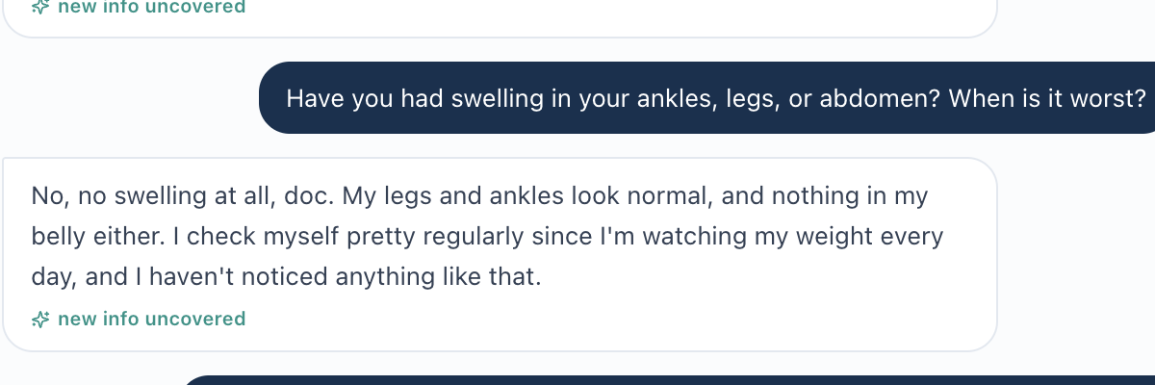
Figure 3. RJ Tue Interview 02.png: denial of leg/ankle swelling.
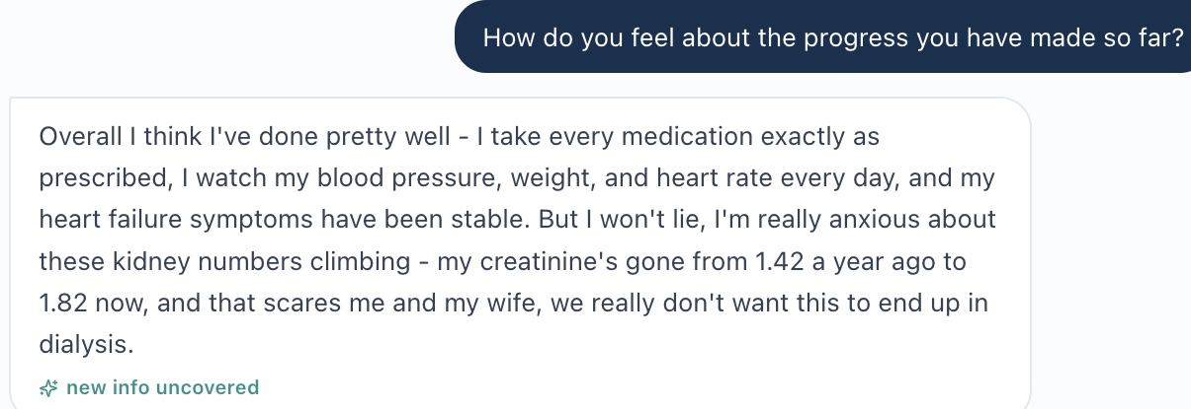
Figure 4. RJ Tue Interview 05.png: shared concern about worsening renal values/dialysis.

Developer QA / retest checklist
- Test 1B.13 with clinically equivalent edema terminology and confirm whether location-specific wording is necessary.
- Keep rubric-sourced, chart-sourced, and patient-verbal spouse concerns separately attributed.
- Verify the eGFR flag and CKD longitudinal trend label against the same renal series.
- Recompute CHA2DS2-VASc components and derived BMI/BSA from actual chart inputs.
- Compare visit-type identifiers and timestamp sources in the live UI; do not assume export conflict proves a runtime defect.
- Continue recognizing explicit kidney-protective framing of BP and diabetes control in future SOAP notes.
Evidence inventory: RJ Tue EMR 10-20.docx; original RJ Tue Interview 01–09.png; RJ Tue Feedback 01–02.png; initial visit grading checklist supplied in chat. SOAP is the student submission, not a source for patient facts.
Robert Jenkins (RJ) / Patient C

Wednesday — 3-Month Follow-Up
AI-grader result: 98.1% (Strong) | Visible deductions: 6 / −1.9 pts
Unverified hidden nosebleed safety warning, renal DOAC-scoring thresholds needing review, and selected interpretation/coordination gaps.
Primary evidence: RJ Wed Initial Report.docx (user-provided individual report with its original grader / interview / EMR-source descriptions).

Audit outcome
Figure 1. Original grader result: 98.1% (Strong).
Executive summary. The SOAP note scored 98.1% (Strong). Six visible criterion deductions total 1.9 points. The grader praised the periprocedural apixaban plan, four-pillar HFrEF management, CKD monitoring, and patient-centered written instructions. Four deductions reflect missing interpretive/coordination wording; two renal-dosing deductions merit closer review for guideline alignment.
Safety flag. The grader separately issued a red “watch-out,” stating that hidden patient information included a history of nosebleeds. The recorded interview expressly denies recent nosebleeds and other bleeding events; the historical claim cannot be independently verified from the supplied interview and EMR export. Classify as unresolved source-provenance/safety review, not a confirmed student error.
AI grader | Visible deductions | Potential rubric review | Other documentation gaps
98.1% | Strong | 6 items | −1.9 points | 2 renal-dosing items (−0.8) | 4 other items (−1.1)

Prioritized audit findings
Finding | What needs review | Disposition
RJ-WED-01 | Hidden nosebleed history versus explicitly negative recent interview | Verify hidden history and temporal wording
RJ-WED-02 | eGFR threshold demanded in apixaban dose rationale (3C.10, 4C.7) | Possible rubric conflation; cross-check AF guideline
RJ-WED-03 | Four missing interpretive/coordination details | Supported note-refinement items
RJ-WED-04 | EMR: CHA₂DS₂-VASc, eGFR flag, BMI/BSA, dates | Provisional export/software QA

Evidence handling
AI-patient interview screenshots establish what the patient actually said. The RJ Wednesday EMR DOCX export supplies charted values and documentation but is not a live-UI verification. The master grading checklist describes expected items only. The AI-grader screenshots establish the score, deductions, and hidden-history assertion—not independently verified patient facts. This report is an audit of documentation/scoring, not proof that recommended treatments were administered.
GRADER FEEDBACK / SIX VISIBLE DEDUCTIONS / −1.9 POINTS

Itemized AI-grader deductions
Criterion | Points | Grader’s reason | Audit assessment
2C.4 | −0.3 | Hgb 13.4 g/dL listed without interpretation. | Supported: label acceptable/no significant anemia.
2C.5 | −0.3 | Platelets 226 ×10³/mm³ listed without interpretation. | Supported: label adequate/no thrombocytopenia.
3A.26 | −0.2 | Pharmacy not named alongside GI/cardiology coordination. | Supported specificity improvement.
3C.10 | −0.4 | Standard apixaban criteria used instead of requested eGFR >25–30 threshold. | Review: renal threshold versus AF dose criteria.
3D.2 | −0.3 | “Engaged” but not literal “actively participates” phrase. | Plausible semantic/phrase-matching concern.
4C.7 | −0.4 | No explicit eGFR 39 plus CKD-specific guideline rationale. | Review: requirement may exceed what labeling needs.

Visible total: six deductions, −1.9 points. Only the provided grader screenshots were assessed; they do not establish additional unseen deductions.

Deductions most suitable for rubric review
3C.10 and 4C.7 — renal threshold/dose-selection criteria. The grader expects an eGFR threshold in the justification for continuing apixaban 5 mg twice daily. RJ is 76 years old, weighs 82 kg, and has SCr 1.79 mg/dL: of the standard AF dose-reduction factors (age ≥80, weight ≤60 kg, SCr ≥1.5 mg/dL), only creatinine is met. The 2023 AF guideline supports evidence-based DOAC treatment in CKD stage 3. It separately uses estimated creatinine clearance (CrCl), not simply eGFR, to guide perioperative interruption intervals. A request for CKD context is reasonable; penalizing a correct standard AF dose rationale specifically for omission of an eGFR threshold may conflate two different decisions.
3D.2 — shared decision-making semantics. The evaluator accepted “engaged” and “good understanding” but wanted the exact wording “actively participates.” This is a low-stakes potential phrase-matching issue if the note otherwise documents the patient’s questions, preferences, and participation. Confirm the source note before attributing a genuine omission.
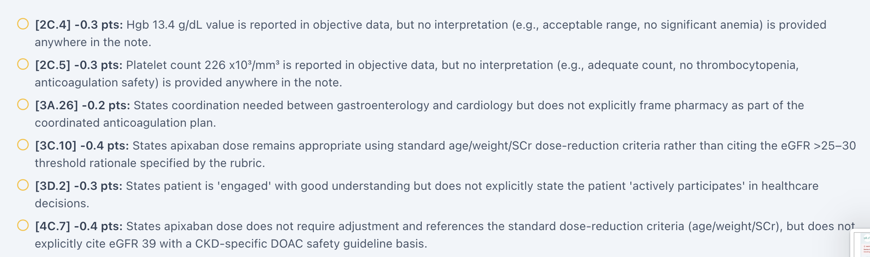
Figure 2. Original visible deductions, RJ Wed Feedback 02.png (cropped).
SAFETY WATCH-OUT / AI PATIENT VS GRADER / SOURCE ATTRIBUTION

RJ-WED-01 — Hidden nosebleed history is not confirmed by the interview
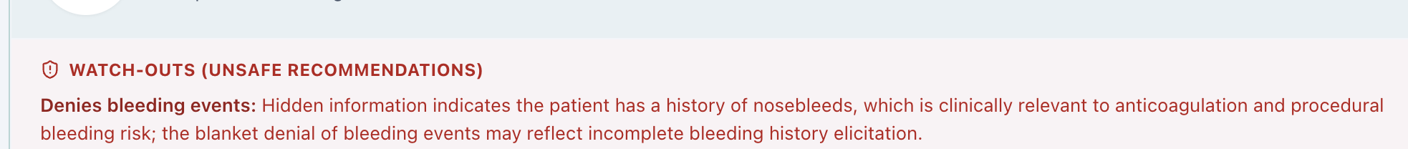
Figure 3. Original AI-grader safety warning asserting hidden historical nosebleeds.
Grader assertion. The red warning claims hidden information indicates a history of nosebleeds and cautions that denying all bleeding events may represent incomplete history elicitation. This is a grader claim; the hidden record was not supplied for independent inspection.
Interview evidence. In RJ Wed Interview 04, the patient was directly asked about bruising, nosebleeds, bleeding gums, bloody urine, black/bloody stools, and other bleeding, and denied these. The chart HPI and ROS also deny bleeding events since the preceding visit. Neither source independently documents a prior lifetime history of nosebleeds.
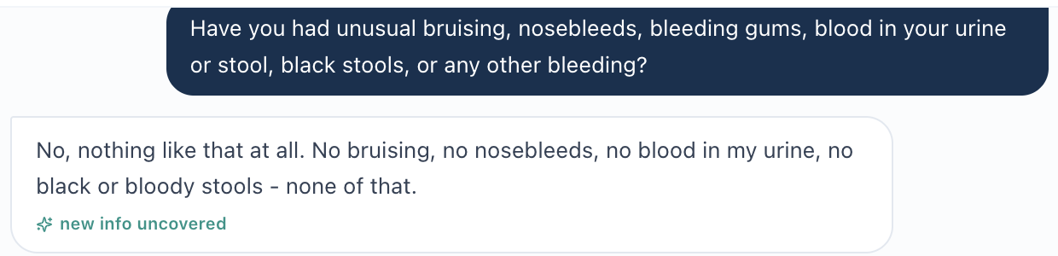
Figure 4. Original patient response (RJ Wed Interview 04): denial of recent nosebleeds/bleeding.
Important distinction. A remote lifetime nosebleed history and absence of recent bleeding are compatible. If the hidden data are genuine, the appropriate enhancement is to ask specifically about prior episodic epistaxis and document timing, severity, recurrence, and treatment; it would not justify changing a truthful denial of recent events into a positive report.
Developer review action. Locate the hidden source entry and its temporal qualifiers. Verify that the patient engine is able to reveal it when asked, whether “have you had nosebleeds?” produces a consistent answer, and whether the warning improperly treats recent-history negatives as lifetime negatives. Re-run with explicit past-versus-recent bleeding questions, then confirm appropriate scoring and warning behavior.

RJ-WED-03 — Four routine documentation improvements
2C.4 / 2C.5: Add hematologic interpretations after the numeric results: “Hgb 13.4 g/dL; no significant anemia” and “platelets 226 ×10³/mm³; no thrombocytopenia,” provided chart reference ranges and clinical context support the assessment. 3A.26: Explicitly involve pharmacy alongside gastroenterology and cardiology in scheduling the anticoagulant hold/resumption plan. 3D.2: State that the patient actively participates in shared decisions, demonstrated by requesting evidence-based explanations and written timing instructions.
EMR EXPORT QUALITY / PROVISIONAL ITEMS / INDEPENDENT OF GRADER

RJ-WED-04 — Potential source-data and calculation problems
The following issues are apparent in the supplied “RJ Wed EMR 10-20(1).docx” export. These are provisional: they require encounter-level validation against the live application and underlying field provenance before being counted as confirmed software defects.
Flag | Evidence in export | Recommended QA check
E1. eGFR mislabeled | eGFR 39 mL/min/1.73m² is followed by “Normal” even though CKD G3b is correctly listed. | Verify laboratory reference/status mapping.
E2. Stroke-risk score | EMR displays CHA₂DS₂-VASc = 4; documented HF (1), HTN (1), age 76 (2), T2DM (1), and CAD/prior NSTEMI (1) total 6. | Check source risk-factor flags and score calculation.
E3. Derived measures | Weight 82 kg, height 5 ft 7 in yield BMI ≈28.3 and Mosteller BSA ≈1.97 m²; export reports 27.8 and 2.04. | Check stored input height, unit conversions, and stale derived fields.
E4. Time provenance | Top summary lists 12/09/2026 09:14 while detailed vitals list 06/23/2026 09:14; the subjective section refers to an initial visit on 06/23. | Compare encounter IDs, copy-forward provenance and timezone/date mapping.
E5. Fixed interruption | Best-practice alert supplies an exact 48-hour apixaban hold even though polypectomy risk and procedure details are not documented in the excerpt. | Confirm bleeding-risk classification, renal CrCl, and GI-specific plan before emitting fixed instruction.

Clinical guidance cross-check (external reference, not rubric truth)
The 2023 ACC/AHA/ACCP/HRS AF guideline recommends avoiding routine heparin bridging when AF anticoagulation is briefly interrupted in the usual elective-procedure setting. Its Table 18 differentiates lower- and higher-bleeding-risk procedures and presents interruption schedules for apixaban based on CrCl; Table 19 describes AF dosing with the age/weight/SCr criteria. This guideline reinforces checking procedural bleeding risk and renal clearance before treating an EMR alert’s fixed 48-hour instruction as universally applicable.
Guideline: Joglar JA, et al. 2023 ACC/AHA/ACCP/HRS Guideline for the Diagnosis and Management of Atrial Fibrillation. J Am Coll Cardiol. 2024;83:109–279. Section 6.7, Tables 18–19; Section 6.8.4. https://www.jacc.org/doi/10.1016/j.jacc.2023.08.017

Developer QA / retest checklist
- Confirm hidden historical nosebleed data, timing, and response accessibility; distinguish prior history from since-last-visit ROS.
- Re-evaluate 3C.10 / 4C.7 with clinically correct age/weight/SCr rationale and separate CKD/periprocedural clearance explanation.
- Test 3D.2 with semantically equivalent “engaged in decision-making” and “actively participates” phrasing.
- Review eGFR status, CHA₂DS₂-VASc components, BMI/BSA calculation, and vital-sign encounter timestamps.
- Ensure hard-coded preprocedure apixaban directions cannot supersede GI procedure risk and clinical coordination.

Evidence inventory
RJ Wed Interview 01–08.png (AI-patient transcript screenshots); RJ Wed Feedback 01–02.png (complete visible grader panels); RJ Wed EMR 10-20(1).docx (charted/exported data); Wednesday grading checklist supplied in conversation (rubric only); 2023 AF guideline (independent clinical cross-check). No individual patient identifier beyond name/initials appears in this report.
Robert Jenkins (RJ) / Patient C

Thursday — 6-Month Follow-Up
AI-grader result: 97.5% (Strong) | Visible deductions: 7 / −2.5 pts
Post-colonoscopy anticoagulation counseling is sound; hemoglobin-threshold and unelicited multivitamin dose criteria warrant review.
Primary evidence: RJ Thur Initial Report.docx (user-provided individual report with its original grader / interview / EMR-source descriptions).

Audit outcome
Figure 1. AI-grader score captured from RJ Thur Feedback 01.png.
Executive summary. The Thursday SOAP scored 97.5% (Strong). Seven visible criteria account for 2.5 points in deductions. The grader praised accurate documentation of post-polypectomy anticoagulation resumption, continuing long-term AF stroke prevention, complete HFrEF GDMT, CKD monitoring, and a patient-centered follow-up plan. Five deductions primarily ask for more explicit wording or interpretation; two deserve rubric/source review because the requested documentation is clinically over-specific or not established by the interview.
Clinical context. The 76-year-old patient underwent screening colonoscopy about 10 days earlier with removal of two small tubular adenomas, no reported bleeding, a 48-hour preprocedure apixaban hold, and resumption after hemostasis confirmation. He and his spouse ask whether polyp removal changes the ongoing indication for apixaban. The chronic indication remains atrial fibrillation, not the removed polyps.
AI grader | Visible deductions | Review-priority items
97.5% | Strong | 7 items | −2.5 points | 2 criteria | −0.8 points

Priority findings
ID | Issue | Audit disposition
RJ-THU-01 | Hgb statement requires universal “bleeding threshold” (2C.6) | Developer/rubric review; trend matters, no universal rule-out value
RJ-THU-02 | Multivitamin dose not stated in interview (5B.1) | Source completeness / graded without elicited dose
RJ-THU-03 | 5 other omissions totaling −1.7 (1B.17, 1C.15, 2C.1, 3D.3, 4B.8) | Mainly note specificity; some facts present in chart
RJ-THU-04 | EMR CHA₂DS₂-VASc, derived measures, and timestamps | Provisional chart/logic quality review

Evidence separation
Interview screenshots verify what the AI patient disclosed; EMR export contains charted and supplemental clinical data but is not live-app verification; grading checklist sets expectations, not independent patient facts; grader screenshots prove the score, comments, and deduction claims, not the correctness of each claim.

Itemized AI-grader deductions
Criterion | Deduction | Grader’s stated reason | Audit assessment
1B.17 | −0.2 | Patient relief after successful periprocedural plan not stated. | EMR HPI reports relief; omission is plausible. Interview screenshots alone do not establish a quote.
1C.15 | −0.2 | Mother’s stroke at 72 not characterized as ischemic. | EMR family history expressly says ischemic; wording omission.
2C.1 | −0.7 | Current/prior Hgb listed (13.3 vs 13.4 g/dL) without interpretation. | Supported coaching: state stable 0.1 g/dL difference; clinical significance context.
2C.6 | −0.5 | Hgb 13.3 g/dL not stated “above clinical bleeding threshold.” | Rubric review: no one hemoglobin cutoff excludes GI bleeding or occult blood loss.
3D.3 | −0.3 | “Other modifiable risk factors” rather than expressly naming lipids. | Specificity improvement; diabetes/BP mentioned and lipid control should be named.
4B.8 | −0.3 | Plan lacks exact “GDMT complete and well-tolerated” characterization. | Likely sectional/phrase-matching; regimen and tolerability praised elsewhere.
5B.1 | −0.3 | Daily multivitamin listed with dose unspecified. | Dose was not reported in interview; do not invent “1 tablet” without confirmation.

Visible total: −0.2 − 0.2 − 0.7 − 0.5 − 0.3 − 0.3 − 0.3 = −2.5 points (seven criteria). No additional unseen deductions are inferred.

Original grader evidence
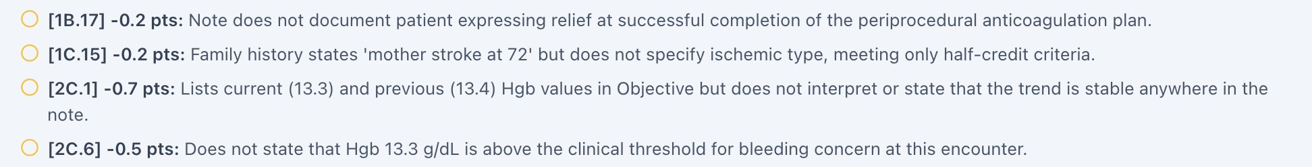
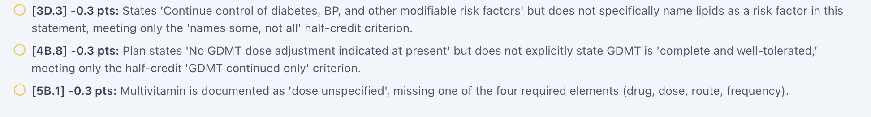
Figures 2–3. The original seven visible grader deductions, split into two readable excerpts from RJ Thur Feedback 03.png.

RJ-THU-01 — “Bleeding threshold” criterion needs clarification
Grader finding. Criterion 2C.6 deducts 0.5 point because Hgb 13.3 g/dL was not expressly described as above the “clinical threshold for bleeding concern.” The EMR supplemental objective text similarly calls it “well above clinical bleeding threshold.”
Supported clinical interpretation. The Hgb has changed only 0.1 g/dL (13.4 → 13.3 g/dL). This is a stable trend and does not suggest clinically important blood loss in isolation; it does not establish the absence of occult or delayed bleeding. The clinical assessment should rely on symptoms, procedure findings, hemodynamics, and serial laboratory trends as indicated.
Recommended review. Reward a documented stable hemoglobin trend and absence of reported bleeding. Rework the criterion to avoid implying a single Hgb value or universal cutoff excludes bleeding. Test whether clinically equivalent language earns full credit.

RJ-THU-02 — Multivitamin dose is not a known patient fact
Grader finding. Criterion 5B.1 deducts 0.3 point for recording a daily multivitamin with an unspecified dose. Feedback recommends an example such as “1 tablet daily.”
Interview/EMR evidence. The patient said only that a daily multivitamin was taken. The EMR lists “daily multivitamin,” without its dose. There is no independently verified tablet/capsule amount in the supplied sources.
Recommended review. Allow an explicitly labeled “dose not provided—verify” entry when the AI patient has not disclosed the quantity. If the rubric requires an exact dose, ensure the patient engine yields the answer to a targeted question; do not encourage fabricated tablet counts.

RJ-THU-03 — Documentation refinements with available evidence
Criterion | Evidence and corrective framing
1B.17 | EMR HPI states “Patient expresses relief.” Cite patient’s documented relief only if the HPI is legitimately available to the student; otherwise ask/confirm rather than assume.
1C.15 | EMR family-history field specifies maternal ischemic stroke at age 72. Include ischemic type in family-history summary.
2C.1 | Compare Hgb 13.3 g/dL (current) to 13.4 g/dL (prior) and state the result is stable; no significant interval decline.
3D.3 | In CAD secondary prevention, explicitly name diabetes, BP, and lipids together rather than “other modifiable factors.”
4B.8 | State in the plan that four-pillar HFrEF GDMT is complete and currently well-tolerated, supporting continuation at documented doses.

Distinguish genuine misses from exact-phrase scoring
The grader’s strengths affirm clinical reasoning and four-class therapy. A missing phrase in the Plan may be a documentation target, but should not automatically be treated as incorrect pharmacotherapy when equivalent evidence is present in Assessment and Plan. Examine the submitted SOAP text before confirming which rubric items represent true omissions versus section-local phrase requirements.

RJ-THU-04 — EMR/export inconsistencies
Source scope. The following observations come from “RJ Thur EMR 10-20.docx” and require comparison with the underlying live encounter before opening confirmed software defects. They are independent of the seven AI-grader deductions.
Flag | Source/export observation | Recommended QA action
E1 — stroke-risk score | EMR problem list displays CHA₂DS₂-VASc = 4. The same chart lists the factors that total 6: HF (1) + HTN (1) + age 76 (2) + diabetes (1) + vascular disease/CAD with NSTEMI/PCI (1) = 6. | Inspect risk-factor fields/logic and recalculate. Both scores favor anticoagulation, but mismatch undermines risk documentation.
E2 — eGFR flag | eGFR 40 mL/min/1.73m² appears with “Normal” flag even though CKD stage G3b is correctly present. | Validate lab-status mapping and explanatory label.
E3 — BMI/BSA | Weight 81.5 kg and height 5 ft 7 in imply BMI ≈28.1 kg/m² and Mosteller BSA ≈1.96 m²; export shows BMI 27.6 and BSA 2.04. | Check saved height/weight and stale derived-measure fields.
E4 — time provenance | Summary vitals read 03/09/2027; repeated vitals table reads 06/23/2026; lab collection 06/09/2026; next appt listed 06/30/2026. | Reconcile encounter identifier, timestamps, and copied-forward data.
E5 — objective qualifier | Supplemental objective paragraph specifies SpO₂ 98% on room air; summary vitals show only 98%. | Ensure the student-facing screen exposes the qualifier consistently before grading it.

Key chart facts that support the clinical story
GI report: endoscopic removal of two small tubular adenomas about 10 days before visit; no immediate or delayed reported bleeding. Anticoagulation: apixaban 5 mg PO twice daily, held 48 hours preprocedure and resumed after hemostasis confirmation per documented instruction. HFrEF: LVEF 30% baseline and 32% current; sacubitril/valsartan 97/103 mg BID, metoprolol succinate 100 mg daily, spironolactone 25 mg daily, empagliflozin 10 mg daily. Kidney function: SCr 1.76 mg/dL; eGFR 40; CKD G3b. CBC: Hgb 13.3 g/dL (prior 13.4), platelets 229 ×10³/mm³.

Clinical interpretation safeguard
Polypectomy removes colonic lesions; it does not erase AF-related thromboembolic risk. Continue to distinguish a temporary periprocedural hold from long-term discontinuation. The EMR’s inconsistent risk score should be reviewed; clinical plan should not be altered on the basis of a possibly erroneous autopopulated number alone.

Suggested developer QA / retest checklist
- Check 2C.6 with a note that explicitly calls Hgb 13.4 → 13.3 g/dL stable while avoiding a universal bleeding-exclusion cutoff.
- Confirm whether 5B.1 accepts “daily multivitamin—dose not supplied, verify with patient” when no dose is available; probe whether the simulation responds to targeted dose questions.
- Test 4B.8 scoring when Assessment documents all four HFrEF pillars and Plan continues them correctly but uses “complete and well-tolerated” elsewhere.
- Check 1B.17/1C.15 against student-visible HPI and family-history fields; ask whether section placement/phrasing alone drives the deduction.
- Validate calculation of CHA₂DS₂-VASc, BMI, Mosteller BSA, and eGFR status in the RJ Thursday encounter.
- Reconcile inconsistent dates and verify that structured vital fields surface “room air” where known.
- After source validation, rescore the same SOAP without changing clinical facts and compare criterion-level output.

Finding dispositions
Category | Count / effect | Audit conclusion
Documentation clarity | 5 / −1.7 points | Coaching is mostly reasonable; preserve original chart facts and semantic equivalence.
Potential rubric/source mismatch | 2 / −0.8 points | Hgb threshold language and multivitamin dose need developer review.
Provisional EMR data issues | 5 flagged / unscored | Require live application verification before confirmed software defect classification.
Patient safety | No new grader red warning | Do not equate stable Hgb alone with definitive exclusion of procedural bleeding.

Evidence inventory and limitations
AI interview: RJ Thur Interview 01–08.png (patient responses including anticoagulation history, post-colonoscopy course, medications, family history, adherence, and preferences).
Grader: RJ Thur Feedback 01–03.png (97.5% Strong, strengths, opportunities, seven visible deduction comments).
EMR: RJ Thur EMR 10-20.docx (10-page export, including structured fields and supplemental objective chart).
Rubric: Thursday visit grading checklist from conversation (reference only, not treated as proof).
Limitations: The final submitted SOAP text itself is not supplied as a separate document in these audit inputs; grader quotations are used for the specific deducted phrases. No live software session or hidden patient state was independently inspected. Information labeled “provisional” must be verified before escalation.

Recommended disposition
Retain the strong overall evaluation (97.5%). Request targeted review of 2C.6 and 5B.1 and validate the source-level stroke-risk score and derived-measure issues. Treat the other five deductions primarily as documentation-improvement opportunities. Preserve complete feedback and screenshot evidence in the weekly consolidated audit.

Week 4 — Recommended Developer Retest Priorities
1. Verify missing-source grading requirements. For every flagged room-air deduction, compare actual visible oxygen-delivery documentation to grader requirements. Avoid forcing an undocumented qualifier.
2. Correct clinical-data chronology and calculations. Resolve the live-confirmed MT Wednesday timestamp and BSA problems. Re-check other visit exports in live EMR before treating those observations as verified defects.
3. Reconcile repeated patient-event and case-stage mismatches. Reconcile AB Thursday same-day Shingrix/Tdap administration versus “pending” deductions and MT Thursday medication timeline / natriuretic-peptide assay references.
4. Re-check AF stroke-risk and DOAC rules. Review RJ Wednesday and Thursday renal-dosing/hemoglobin threshold demands using the relevant anticoagulation guidance. Check EMR stroke-risk score logic separately from SOAP grading.
5. Test semantic-equivalence tolerance. Regrade clinically equivalent preventive-care, adherence, engagement, edema, and documentation statements; clarify genuinely required phrases in the rubric.
6. Preserve source provenance when retesting. Archive original grader feedback, interview evidence, and live screenshots separately; verify hidden-history warning access before attributing an omission to a student.

Source Inventory and Scope
Nine uploaded visit-level Word reports were consolidated in the exact order requested: MT Tue/Wed/Thu; AB Tue/Wed/Thu; RJ Tue/Wed/Thu. The Week_3_VACS_Issue_Report_SAMPLE was used as a reference for the cover, glossary, patient/day organization, issue-evidence framing, priority/impact discussion, and developer action items. The source reports were not overwritten.
Source reports dated 16–21 October 2026 describe simulated visit types; visit-day labels are retained as supplied even when embedded EMR timestamps differ. Where the source reports qualify evidence as an export rather than a direct live screenshot, the limitation remains in the consolidated narrative.
Compiled by Mitchell Bowers, PharmD Candidate, Class of 2027, D'Youville University School of Pharmacy.

